Market Review
Source: Zephyr StyleADVISOR

- The quarter began with a short-lived summer rally that fizzled only to set new lows. Record high inflation, aggressive interest rate hikes from global central banks, and fear of recession left no place for investors to hide. For the third quarter, the diversified 60/40 portfolio invested 60% in global stocks, and 40% global bonds returned -6.8% and performed worse than one just invested in global stocks (-6.7%) as global bonds posted dismal returns (-6.9%). Within equities, US stocks sunk back in bear territory to end the quarter -4.9%. Similarly, US bond yields which move in the opposite direction of prices, rose to their highest levels in years as hopes for falling inflation were erased when core inflation rose in August despite falling gas prices.
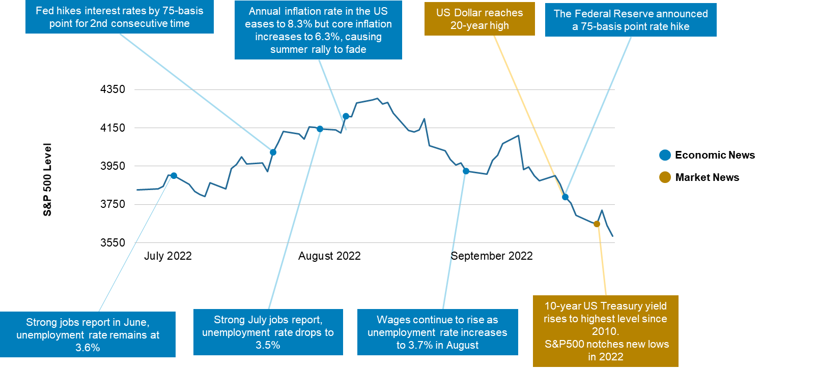
Source: FactSet, CNBC, Trading Economics
- Within US equities, 9 out of 11 sectors suffered losses in 2Q22. Surprisingly, the consumer discretionary sector gained 4.4% for the quarter, helped by select stocks despite having a greater sensitivity to the overall business cycle. However, it remains the second worst performing sector at -29.9% for the year. Similarly, the energy sector gained 2.3% despite falling oil prices during the quarter and remains the only sector with positive returns of 34.9% for the year.

- Value stocks reverse trends and underperform. Growth stocks are often synonymous with the high-flying companies in the markets like technology, while value stocks are often considered undervalued, steady, and sometimes even boring. For the quarter, value stocks underperformed their growth counterparts, a reversal in trends from the prior quarter. Still, large-growth stocks are on pace to have their worst year since 2008.

- International equities underperformed US equities in 3Q22. Developed international, emerging markets ended 3Q22 at -9.3 % and -11.4%, respectively, as the energy crisis and recession fears continued to roil European economies while China continued to struggle under its zero COVID policy. A strong dollar also had a significant impact. Generally speaking, a stronger dollar translates to lower returns for international investments. This can be seen in its local currency returns, especially for developed international, which ended 3Q22 at -3.5%. In local currency, this would put it as one of the better performing developed market equity markets without the currency drag.

- Bonds post steep losses in the third quarter. US bonds fell 4.8% in the quarter as the Fed's aggressive efforts to tame inflation brought two more rate hikes of 0.75%, raising the effective federal-funds rate to 3.00%-3.25%, its highest level since 2008. Despite higher inflation, TIPS fell 5.1% due to rising rates despite inflation concerns. Longer-term Treasuries, which have the greatest sensitivity to interest-rate changes, were the hardest hit and fell by 9.6%. US high yield bonds were surprisingly among the best performing sector and only fell 0.6% despite ongoing recession fears. Lastly, a stronger dollar and inflation woes also led international bonds lower for the quarter.

- Key commodities, including gold, oil, and copper, declined over concerns of weaker demand due to global economic slowdown. Oil prices fell below $80/barrel to their lowest levels since Jan '22. Gold prices fell 7.9% for the quarter and have failed to meet expectations as an inflation hedge or a safe haven investment in 2022. Expectations for higher interest rates in the US led the dollar to rally 7.8% for the quarter and 17.6% for the year. One notable exception within commodities were grains, specifically wheat, with strong gains for the quarter as the conflict in Ukraine continues to impact the world supply. Finally, US REITs lost 10.8% for the quarter over concerns of rising costs due to higher interest rates.

Asset classes are represented by the following indexes:
US Equities | S&P 500 – is an unmanaged index that is generally considered representative of the US equity market, consisting of 500 leading companies in leading industries of the US economy (typically large cap companies) representing approximately 75% of the investable US equity market.
International Equities | MSCI EAFE – is a free float-adjusted market capitalization weighted index that is designed to measure the equity market performance of countries considered to represent developed markets, excluding the U.S. and Canada.
Emerging Markets Equities | MSCI Emerging Markets – is a free float-adjusted, market capitalization index that is designed to measure the equity market performance of countries considered to represent emerging markets.
Global Equity | MSCI ACWI - measures large- and mid-cap equity performance of developed and emerging markets. Represents approximately 85% of the global equity investment universe.
US Small Cap Growth | S&P 600 Growth - measures the performance of the small cap growth segment of the US equity market.
US Small Cap Value | S&P 600 Value - measures the performance of the small cap value segment of the US equity market.
US Mid Cap Value | S&P 400 Value – measures the performance of the mid cap value segment of the US equity market.
US Mid Cap Growth | S&P 400 Growth – measures the performance of the mid cap growth segment of the US equity market
US Large Cap Value | S&P 500 Value – measures the performance of the large cap value segment of the US equity market
US Large Cap Growth | S&P 500 Growth – measures the performance of the large cap growth segment of the US equity market
US Bonds | Bloomberg US Aggregate — measures the market of USD-denominated, investment grade, fixed-rate taxable bond market of SEC-registered securities, including bonds from the Treasury, government-related, corporate, mortgage-backed securities (agency fixed-rate and hybrid ARM passthroughs), ABS and CMBS sectors. US Agency Hybrid Adjustable Rate Mortgage (ARM) securities were added to the US Aggregate Index on April 1, 2007.
International Bonds | Bloomberg Global Aggregate ex USD - is a flagship hard currency Emerging Markets debt benchmark that includes fixed and floating-rate US dollar-denominated debt issued from sovereign, quasi-sovereign, and corporate EM issuers. Country eligibility and classification as Emerging Markets is rules-based and reviewed annually using World Bank income group and International Monetary Fund (IMF) country classification.
Emerging Markets Bonds | Bloomberg Emerging Markets USD Aggregate - is a flagship hard currency Emerging Markets debt benchmark that includes fixed and floating-rate US dollar-denominated debt issued from sovereign, quasi-sovereign, and corporate EM issuers. Country eligibility and classification as Emerging Markets is rules-based and reviewed annually using World Bank income group and International Monetary Fund (IMF) country classification.
Global Bonds | Barclays Global Aggregate - measures the performance of global, investment-grade debt from 24 local currency markets. This benchmark includes treasury, government-related, corporate and securitized fixed-rate bonds from both developed and emerging markets issuers.
TIPS | Bloomberg US TIPS - measures the performance of inflation-protected securities issued by the US Treasury.
US Long Treasuries | Bloomberg Long Treasuries - measures the performance of long-term US Treasury bonds, including all publicly issued securities that have a remaining maturity of ten or more years, are: non-convertible, denominated in US dollars, rated investment-grade, fixed-rate and have $250 or more of outstanding face value.
High-Yield Bonds | Bloomberg US Corporate High Yield - measures the market of USD-denominated, non-investment grade, fixed-rate, taxable corporate bonds. Securities are classified as high yield if the middle rating of Moody's, Fitch, and S&P is Ba1/BB+/BB+ or below. The index excludes emerging market debt.
Consumer Discretionary | S&P 500 Consumer Discretionary Sector - measures the performance of companies involved in industries such as: automobiles and components, consumer durables, apparel, hotels, restaurants, leisure, media and retailing.
Real Estate | S&P 500 Sector Real Estate - measures the performance of companies from the following industries: real estate management & development and REITS, excluding mortgage REITS.
Energy | S&P 500 Sector Energy - measures the performance of companies involved in the development and production of crude oil, natural gas and provide drilling and other energy-related services.
US REITs | FTSE NAREIT All Equity REIT - measures the price of physical commodities futures contracts traded on US exchanges, except aluminum, nickel and zinc, which trade on the London Metal Exchange. Weightings are determined by rules designed to insure diversified commodity exposure.
Gold | Bloomberg Sub Gold - measures the price of gold futures contracts, reflecting the return of underlying commodity futures price movements quoted in USD.
Commodities | Bloomberg Commodity - dynamically rebalances exposure to maintain a 10% volatility target and represents portfolios consisting of the S&P 500 index and a cash component accruing interest. Uses S&P 500 methodology and overlays algorithms to control the index risk at specific volatility targets.
US Dollar | US Dollar Index - measures the value of the US dollar relative to the value of a 'basket' of currencies of the majority of the U.S.'s most significant trading partners. Factors the exchange rates of six major world currencies: euro, Japanese yen, Canadian dollar, British pound, Swedish krona and Swiss franc.

IMPORTANT INFORMATION
This report is for informational purposes only, and is not a solicitation, and should not be considered as investment or tax advice. The information has been drawn from sources believed to be reliable, but its accuracy is not guaranteed, and is subject to change. Opinions are those of AssetMark and may change at any time. Investors seeking more information should discuss with their financial advisor. Financial advisors may seek more information regarding all services offered through the AssetMark platform by contacting AssetMark at 800-664-5345.
Investing involves risk, including the possible loss of principal. Past performance does not guarantee future results. Asset allocation alone cannot eliminate the risk of fluctuating prices and uncertain returns. There is no guarantee that a diversified portfolio will outperform a non-diversified portfolio in any given market environment. No investment strategy, such as asset allocation, can guarantee a profit or protect against a loss. Actual client results will vary based on investment selection, timing, and market conditions. The market indices shown are non-managed indices shown for reference purposes. Index performance reflects the reinvestment of dividends. It is not possible to invest directly in an index, and index performance does not reflect any deduction for investment advisory fees.
Please read the Terms of Use posted at www.ewealthmanager.com that govern the use of these materials and also be advised:
AssetMark uses financial market information (“Information”) from third-party providers (“Providers”) in reports (“Materials”). The Information includes, but is not limited to, financial market data, quotes, news, analyst opinions and research reports. The Materials are for informational purposes only, not a solicitation or for use in the creation/management/offering/sale of any financial instrument or product based thereon and should not be considered investment, legal or tax advice. The Information has been drawn from sources believed to be reliable, but its accuracy and timeliness is not guaranteed, and is subject to change. You agree that neither AssetMark nor the Providers are liable for the use of the Information.
You agree not to redistribute the Information to recipients not authorized by AssetMark. You agree that the Providers are considered to be third-party beneficiaries of the Terms of Use.
AssetMark, Inc. is an investment adviser registered with the Securities and Exchange Commission.
©2022 AssetMark, Inc. All rights reserved.
103363 | C22-19267 |10/2022 | EXP 10/31/2024

AssetMark, Inc.
1655 Grant Street
10th Floor
Concord, CA 94520-2445
800-664-5345

