Market Review

- As the global economy recovers from the pandemic with varying degrees of success, global stock and bond markets posted broad gains in the second quarter.

Source: FactSet financial data and analytics

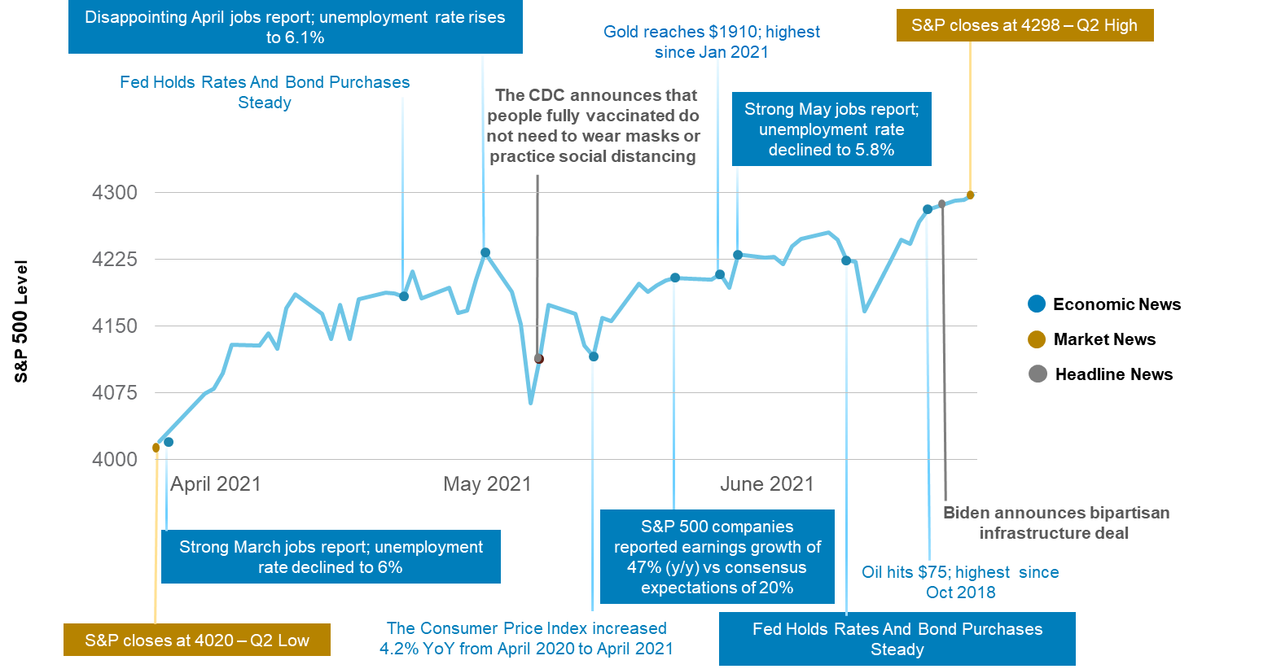
- Notable among them was US equities which gained 8.5% for the second quarter and 15.3% for the year led by easy monetary and fiscal policy, like potential infrastructure spending, strong economic recovery and robust corporate earnings. In the first half of 2021, US equities marked 34 record highs and the largest gains since 2019. As equity markets have rallied, volatility fell to pre-pandemic lows.

Source: FactSet, CNBC, CNN, Reuters, Yahoo Finance, NY Times, JPMorgan, US Bureau of Labor Statistics
- International markets trailed US equity markets for both the quarter and the year. Developed international markets gained 5.4% and trailed US equities due to negative returns in Japan over slow vaccination efforts. Finally, regulatory and policy tightening concerns in China held back emerging market equities to a 5.1% gain for the quarter.
- Within the US sector, performance was varied with results ranging from 13.1% for real estate to -0.4% for utilities. Real estate continued its climb benefiting from the re-openings across the country. Energy was the third best performing sector which gained 11.3%, as Brent crude oil prices crossed $75 per barrel for the first time since 2018. Energy remains the top performing sector for the year, up 45.6% as oil prices commensurately climbed 50% in 2021. Finally, the strong economic recovery made a traditionally defensive sector like utilities less attractive relative to other sectors and lost -0.4%

- The outperformance of economically sensitive value stocks that dominated the market since the news of an effective vaccine in late 2020 reversed course in the second quarter. Growth stocks outperformed value stocks as technology shares surged on falling interest rates and better earnings expectations. For the quarter, large- and mid-cap growth stocks beat their value counterparts, but small-cap value still led small-cap growth.

- In the bond market, after the Federal Reserve acknowledged it was on watch for inflation, the yield of the 10-year Treasury note fell 30 basis points to 1.45% from a high of 1.74% in March. As rates fell US bonds gained 1.8% during the quarter but was unable to reverse the losses from prior quarter and remains negative (-1.6%) for the year. High-yield bonds gained 2.7% for the quarter and 3.6% for the year and continues to outpace government and corporate bonds.

- REITs continued its climb, returning 12% for the quarter and 21.3% for the year. Commodities also gained 13.3% in the second quarter, led by energy which was up 23% for the quarter. Inflation concerns also led gold and silver higher by 3.5%, and 6.2% respectively for the quarter. However, gold remains down -7% for the year. In REITS, with the exception of hotels, all other REIT sectors saw positive returns with self-storage up nearly 24% for the quarter.

Asset classes are represented by the following indexes:
US Equities | S&P 500 – is an unmanaged index that is generally considered representative of the US equity market, consisting of 500 leading companies in leading industries of the US economy (typically large cap companies) representing approximately 75% of the investable US equity market.
International Equities | MSCI EAFE – is a free float-adjusted market capitalization weighted index that is designed to measure the equity market performance of countries considered to represent developed markets, excluding the U.S. and Canada.
Emerging Markets Equities | MSCI Emerging Markets – is a free float-adjusted, market capitalization index that is designed to measure the equity market performance of countries considered to represent emerging markets.
US Bonds | Barclays US Aggregate — measures the market of USD-denominated, investment grade, fixed-rate taxable bond market of SEC-registered securities, including bonds from the Treasury, government-related, corporate, mortgage-backed securities (agency fixed-rate and hybrid ARM passthroughs), ABS and CMBS sectors. US Agency Hybrid Adjustable Rate Mortgage (ARM) securities were added to the US Aggregate Index on April 1, 2007.
International Bonds | Bloomberg Barclays Global Aggregate ex USD - is a flagship hard currency Emerging Markets debt benchmark that includes fixed and floating-rate US dollar-denominated debt issued from sovereign, quasi-sovereign, and corporate EM issuers. Country eligibility and classification as Emerging Markets is rules-based and reviewed annually using World Bank income group and International Monetary Fund (IMF) country classification.
Emerging Markets Bonds | Bloomberg Barclays Emerging Markets USD Aggregate - is a flagship hard currency Emerging Markets debt benchmark that includes fixed and floating-rate US dollar-denominated debt issued from sovereign, quasi-sovereign, and corporate EM issuers. Country eligibility and classification as Emerging Markets is rules-based and reviewed annually using World Bank income group and International Monetary Fund (IMF) country classification.
Small Caps | S&P 600 - measures the performance of 600 small-sized companies in the U.S. Constituents generally have a market-cap between $400 million and $1.8 billion and meet criteria to ensure they are liquid and financially viable.
Energy | S&P 500 Energy Sector -measures the performance of companies in an array of diversified financial service firms, insurance, banks, capital markets, consumer finance and thrift companies.
Real Estate | S&P 500 Sector Real Estate - measures the performance of companies from the following industries: real estate management & development and REITS, excluding mortgage REITS.
Technology | S&P 500 Technology Sector - measures the performance of companies that product, generate, transmit or distribute electricity, water or natural gas, and also includes power producers & energy traders and companies that engage in generation and distribution of electricity using renewable sources.
Utilities | S&P 500 Sector Utilities - measures the performance of companies that product, generate, transmit or distribute electricity, water or natural gas, and also includes power producers & energy traders and companies that engage in generation and distribution of electricity using renewable sources.
EM Latin America | MSCI Emerging Markets Latin America - measures the performance of USD-denominated, investment-grade, fixed-rate taxable bond market of SEC-registered securities. The index includes Treasury bonds, Government-related Corporate, MBS (agency fixed-rate and hybrid ARM pass-throughs), ABS and CMBS sectors.
China | MSCI China - measures the performance of small-cap equities in developed market countries around the world, excluding the U.S. and Canada. The index covers approximately 14% of the market cap in each country.
Long term Treasuries | Bloomberg Barclays US Treasury Long - measures the performance of US Treasury and US Agency markets. The index includes USD-denominated fixed-rate, nominal US Treasuries and US agency debentures (securities issued by the US government-owned or sponsored entities), and explicitly guaranteed by the US government.
High-Yield Bonds | Bloomberg Barclays US Corporate High Yield - measures the market of USD-denominated, non-investment grade, fixed-rate, taxable corporate bonds. Securities are classified as high yield if the middle rating of Moody’s, Fitch, and S&P is Ba1/BB+/BB+ or below. The index excludes emerging market debt.
Leveraged Loans | S&P/LSTA Leveraged Loans - measures the performance of investment-grade fixed-rate mortgage-backed pass-through securities of GNMA, FNMA and FHLMC.
Commodities | Bloomberg Commodity.- dynamically rebalances exposure to maintain a 10% volatility target and represents portfolios consisting of the S&P 500 index and a cash component accruing interest. Uses S&P 500 methodology and overlays algorithms to control the index risk at specific volatility targets.
Precious Metals | Bloomberg Precious Metals - measures the price of gold futures contracts, reflecting the return of underlying commodity futures price movements quoted in USD.
US REITs | FTSE NAREIT All Equity REIT - measures the price of physical commodities futures contracts traded on US exchanges, except aluminum, nickel and zinc, which trade on the London Metal Exchange. Weightings are determined by rules designed to insure diversified commodity exposure.

IMPORTANT INFORMATION
This report is for informational purposes only, and is not a solicitation, and should not be considered as investment or tax advice. The information has been drawn from sources believed to be reliable, but its accuracy is not guaranteed, and is subject to change. Opinions are those of AssetMark and may change at any time. Investors seeking more information should discuss with their financial advisor. Financial advisors may seek more information regarding all services offered through the AssetMark platform by contacting AssetMark at 800-664-5345.
Investing involves risk, including the possible loss of principal. Past performance does not guarantee future results. Asset allocation alone cannot eliminate the risk of fluctuating prices and uncertain returns. There is no guarantee that a diversified portfolio will outperform a non-diversified portfolio in any given market environment. No investment strategy, such as asset allocation, can guarantee a profit or protect against a loss. Actual client results will vary based on investment selection, timing, and market conditions. The market indices shown are non-managed indices shown for reference purposes. Index performance reflects the reinvestment of dividends. It is not possible to invest directly in an index, and index performance does not reflect any deduction for investment advisory fees.
AssetMark, Inc. is an investment adviser registered with the Securities and Exchange Commission.
©2021 AssetMark, Inc. All rights reserved.
102640 | C21-17820 | 07/2021 | EXP 07/31/2022

AssetMark, Inc.
1655 Grant Street
10th Floor
Concord, CA 94520-2445
800-664-5345

https://www.marketwatch.com/story/sp-500-books-34th-record-of-2021-as-dow-closes-up-over-200-points-nears-may-7-record-high-2021-06-30
https://fred.stlouisfed.org/series/VIXCLS
https://am.jpmorgan.com/ch/en/asset-management/adv/insights/market-insights/monthly-market-review/
https://www.macrotrends.net/2480/brent-crude-oil-prices-10-year-daily-chart
https://www.treasury.gov/resource-center/data-chart-center/interest-rates/pages/TextView.aspx?data=yieldYear&year=2021

