Market Review
Source: FactSet financial data and analytics

- The war in Ukraine, surging inflation and rising interest rates led markets lower in the first quarter. After a strong 2021, US equities saw its first quarterly loss in two years. During the quarter at its worst, US equities fell 13% and thus into official correction territory (defined as a drop of 10%). While this may be shocking, it remains in line with historical intra-year declines. Since 1980, despite average intra-year drops of 14.0%, annual returns were positive in 32 of 42 years. Despite ongoing uncertainty, US equities staged a strong late rebound of nearly 9% to end the quarter at -4.6%.
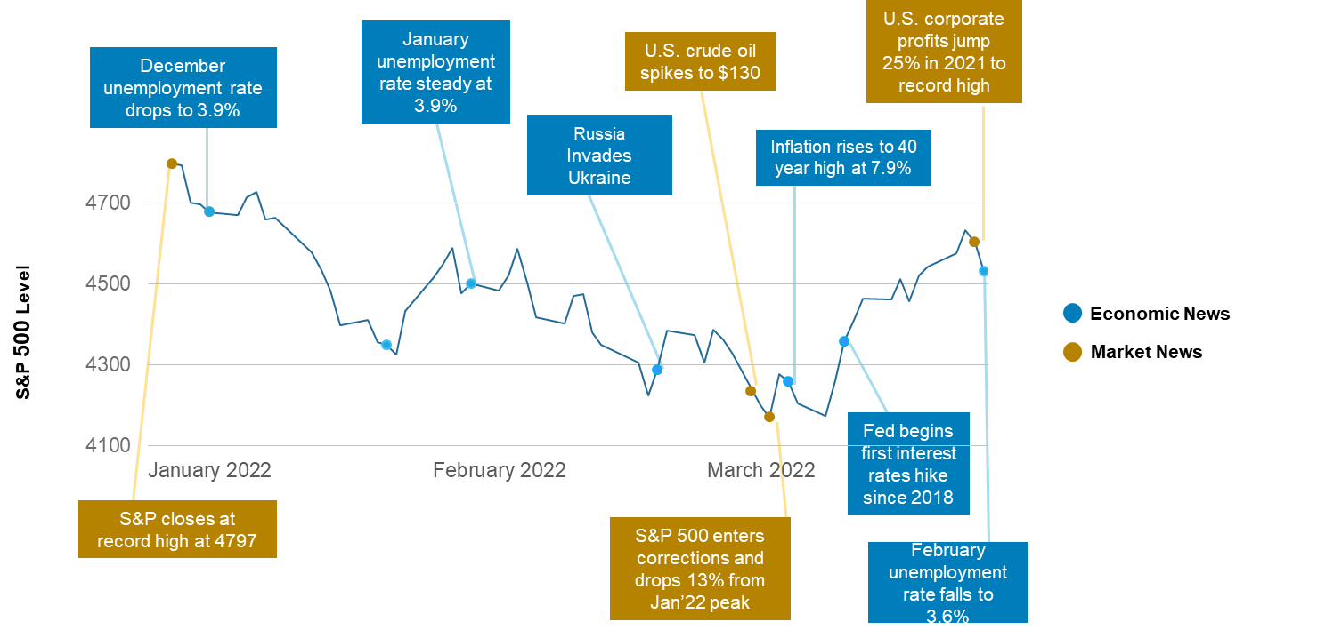

Source: Zephyr StyleADVISOR, Standard & Poor’s, FactSet, CNBC, CNN, CBS, MarketWatch, Forbes
- Within US equities, nine out of 11 sectors suffered losses in 1Q22. Two sectors with positive returns included Energy and Utilities. Energy sector gained 39% on surging oil prices. Utilities, often considered a defensive sector, also gained 4.8%. Technology related sectors like Communication Services (-11.9%) and Consumer Discretionary (-9.0%) were the worst performers amid fears of rising rates and a slowing economy.

- Elevated valuations and rising interest rates hurt long-duration growth stocks. The gap between value and growth stocks across size and style was stark and was significantly in favor of larger and value-oriented segments. Large cap value stocks outperformed large cap growth by 8.3%.

- Within international equity markets, both developed and emerging markets fell 5.8% and 6.9% respectively in 1Q22. The conflict in Ukraine weighed heavily on European markets, given its reliance on Russian energy. Additionally, emerging markets, particularly China, struggled as continued COVID-19 lockdowns remained highly disruptive to its economy.

- Bonds had their worst quarter in 20 years. US bonds fell 5.9% in 2022 as interest rates rose after the Federal Reserve set out on a more aggressive path to tame inflation. Despite higher inflation, TIPS also fell 3% due to rising rates. Longer-term Treasuries, which have the greatest sensitivity to interest-rate changes, were the hardest hit and fell 10.6%. US high yield bonds fell 4.8% due to the flight to quality stemming from the Russia-Ukraine conflict. Lastly, a stronger dollar and inflation woes also led international bonds lower for the quarter.

- Commodities were the biggest winners as the war in Ukraine fueled further inflationary pressures leading to a surge in oil and grain prices. Gold gained 6.6%, living up to its reputation as a safe haven during the market selloff. Expectations for higher interest rates in the US led the dollar to rally 2.6%. After a record 2021, US REITs lost 5.3% over concerns of rising costs due to higher interest rates. However, gains were recorded within subsectors such as hotels and offices, as they continue to benefit from easing economic restrictions.

Asset classes are represented by the following indexes:
US Equities | S&P 500 – is an unmanaged index that is generally considered representative of the US equity market, consisting of 500 leading companies in leading industries of the US economy (typically large cap companies) representing approximately 75% of the investable US equity market.
International Equities | MSCI EAFE – is a free float-adjusted market capitalization weighted index that is designed to measure the equity market performance of countries considered to represent developed markets, excluding the U.S. and Canada.
Emerging Markets Equities | MSCI Emerging Markets – is a free float-adjusted, market capitalization index that is designed to measure the equity market performance of countries considered to represent emerging markets.
China | MSCI China - measures the performance of small-cap equities in developed market countries around the world, excluding the U.S. and Canada. The index covers approximately 14% of the market cap in each country.
US Small Cap Growth | S&P 600 Growth - measures the performance of the small cap growth segment of the US equity market.
US Small Cap Value | S&P 600 Value - measures the performance of the small cap value segment of the US equity market.
US Mid Cap Value | S&P 400 Value – measures the performance of the mid cap value segment of the US equity market.
US Mid Cap Growth | S&P 400 Growth – measures the performance of the mid cap growth segment of the US equity market
US Large Cap Value | S&P 500 Value – measures the performance of the large cap value segment of the US equity market
US Large Cap Growth | S&P 500 Growth – measures the performance of the large cap growth segment of the US equity market
US Bonds | Bloomberg US Aggregate — measures the market of USD-denominated, investment grade, fixed-rate taxable bond market of SEC-registered securities, including bonds from the Treasury, government-related, corporate, mortgage-backed securities (agency fixed-rate and hybrid ARM passthroughs), ABS and CMBS sectors. US Agency Hybrid Adjustable Rate Mortgage (ARM) securities were added to the US Aggregate Index on April 1, 2007.
International Bonds | Bloomberg Global Aggregate ex USD - is a flagship hard currency Emerging Markets debt benchmark that includes fixed and floating-rate US dollar-denominated debt issued from sovereign, quasi-sovereign, and corporate EM issuers. Country eligibility and classification as Emerging Markets is rules-based and reviewed annually using World Bank income group and International Monetary Fund (IMF) country classification.
Emerging Markets Bonds | Bloomberg Emerging Markets USD Aggregate - is a flagship hard currency Emerging Markets debt benchmark that includes fixed and floating-rate US dollar-denominated debt issued from sovereign, quasi-sovereign, and corporate EM issuers. Country eligibility and classification as Emerging Markets is rules-based and reviewed annually using World Bank income group and International Monetary Fund (IMF) country classification.
TIPS | Bloomberg US TIPS - measures the performance of inflation-protected securities issued by the US Treasury.
US Long Treasuries | Bloomberg Long Treasuries - measures the performance of long-term US Treasury bonds, including all publicly issued securities that have a remaining maturity of ten or more years, are: non-convertible, denominated in US dollars, rated investment-grade, fixed-rate and have $250 or more of outstanding face value.
High-Yield Bonds | Bloomberg US Corporate High Yield - measures the market of USD-denominated, non-investment grade, fixed-rate, taxable corporate bonds. Securities are classified as high yield if the middle rating of Moody’s, Fitch, and S&P is Ba1/BB+/BB+ or below. The index excludes emerging market debt.
Utilities | S&P 500 Sector Utilities - measures the performance of companies that product, generate, transmit or distribute electricity, water or natural gas, and also includes power producers & energy traders and companies that engage in generation and distribution of electricity using renewable sources.
Communication Services | S&P 500 Sector Communication Services - measures the performance of companies from the media, retailing, and software & services industries in the U.S.
Consumer Discretionary | S&P 500 Consumer Discretionary Sector - measures the performance of companies involved in industries such as: automobiles and components, consumer durables, apparel, hotels, restaurants, leisure, media and retailing.
Real Estate | S&P 500 Sector Real Estate - measures the performance of companies from the following industries: real estate management & development and REITS, excluding mortgage REITS.
Energy | S&P 500 Sector Energy - measures the performance of companies involved in the development and production of crude oil, natural gas and provide drilling and other energy-related services.
US REITs | FTSE NAREIT All Equity REIT - measures the price of physical commodities futures contracts traded on US exchanges, except aluminum, nickel and zinc, which trade on the London Metal Exchange. Weightings are determined by rules designed to insure diversified commodity exposure.
Gold | Bloomberg Sub Gold - measures the price of gold futures contracts, reflecting the return of underlying commodity futures price movements quoted in USD.
Commodities | Bloomberg Commodity - dynamically rebalances exposure to maintain a 10% volatility target and represents portfolios consisting of the S&P 500 index and a cash component accruing interest. Uses S&P 500 methodology and overlays algorithms to control the index risk at specific volatility targets.
US Dollar | US Dollar Index - measures the value of the US dollar relative to the value of a 'basket' of currencies of the majority of the U.S.'s most significant trading partners. Factors the exchange rates of six major world currencies: euro, Japanese yen, Canadian dollar, British pound, Swedish krona and Swiss franc.

IMPORTANT INFORMATION
This report is for informational purposes only, and is not a solicitation, and should not be considered as investment or tax advice. The information has been drawn from sources believed to be reliable, but its accuracy is not guaranteed, and is subject to change. Opinions are those of AssetMark and may change at any time. Investors seeking more information should discuss with their financial advisor. Financial advisors may seek more information regarding all services offered through the AssetMark platform by contacting AssetMark at 800-664-5345.
Investing involves risk, including the possible loss of principal. Past performance does not guarantee future results. Asset allocation alone cannot eliminate the risk of fluctuating prices and uncertain returns. There is no guarantee that a diversified portfolio will outperform a non-diversified portfolio in any given market environment. No investment strategy, such as asset allocation, can guarantee a profit or protect against a loss. Actual client results will vary based on investment selection, timing, and market conditions. The market indices shown are non-managed indices shown for reference purposes. Index performance reflects the reinvestment of dividends. It is not possible to invest directly in an index, and index performance does not reflect any deduction for investment advisory fees.
Please read the Terms of Use posted at www.ewealthmanager.com that govern the use of these materials and also be advised:
AssetMark uses financial market information (“Information”) from third-party providers (“Providers”) in reports (“Materials”). The Information includes, but is not limited to, financial market data, quotes, news, analyst opinions and research reports. The Materials are for informational purposes only, not a solicitation or for use in the creation/management/offering/sale of any financial instrument or product based thereon and should not be considered investment, legal or tax advice. The Information has been drawn from sources believed to be reliable, but its accuracy and timeliness is not guaranteed, and is subject to change. You agree that neither AssetMark nor the Providers are liable for the use of the Information.
You agree not to redistribute the Information to recipients not authorized by AssetMark. You agree that the Providers are considered to be third-party beneficiaries of the Terms of Use.
AssetMark, Inc. is an investment adviser registered with the Securities and Exchange Commission.
©2022 AssetMark, Inc. All rights reserved.
103921 | C22-18672 | 04/2022 | EXP 04/31/2024

AssetMark, Inc.
1655 Grant Street
10th Floor
Concord, CA 94520-2445
800-664-5345

JPMorgan Guide to the Markets. Q1’2022
https://www.morningstar.com/articles/1087132/13-charts-on-the-markets-first-quarter-performance

