Time in vs Timing the Markets
The stock market is off to a rocky start this year. Higher volatility can be a source of uncertainty for even the most seasoned investors. In this issue we hope to provide some historical perspective on the anatomy of the markets and the impact of moving out of markets during periods of turbulence.
Volatility is a Feature and Not a Bug in the Market
History tells us that market volatility is a feature of how the market functions and not a bug. Research by Ned Davis on the anatomy of the stock market (Dow Jones Index) highlights the frequency of market declines since 1900. This research found that on average, every year the market suffers three 5% corrections, one 10% correction, and a decline of 20% every three years or more. Market history also suggests that most dips (declines of 5%) in the Dow Jones Industrial Average don’t turn into anything serious.
Time in vs Market Timing
Since market pullbacks are frequent, avoiding just a few of them could potentially add to investment results. However, attempts to avoid pullbacks more often lead to missing out on significant advances. A reason is that market volatility is often clustered with the big moves in the market, both up and down, occurring within days of each other.
As an example, an investor who remained fully invested in the S&P 500 Index during 2020 saw a total return of 18.4%. On the other hand, if an investor sold when the market dropped, not only would they have possibly avoided some of the losses, but they could have also potentially missed the trading days with the greatest gains. Research shows that simply missing the top 10 trading days in 2020 would have led not only to giving up the gains, but an investor would have experienced a loss of 32.9%.
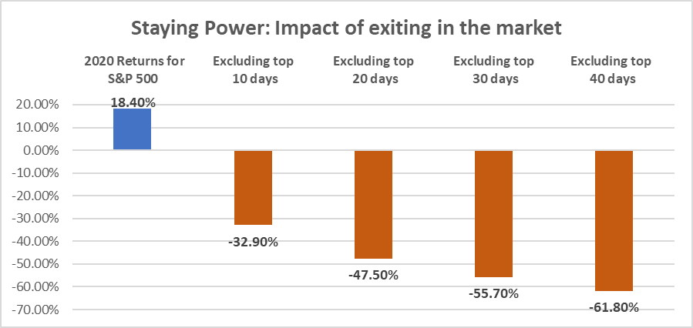
Source: Schwab Center for Financial Research
This phenomenon is not isolated to 2020. Over the last fifteen years, a time period which includes the great financial recession, as well as the COVID-driven recession, an investor who remained invested in S&P 500 index would have generated an annualized return of 10.66%. However, simply missing the top 10 days would cut returns by 50% to 5.05% annualized returns. The results become more dramatic when simply missing the top 30 days leads to annualized losses of -1.18%.
A Key to Long-Term Investing Success
Understandably, the market’s normal ups and downs can be stressful. While it’s natural to have a reaction to market volatility, it’s also important to understand the potential impact of that reaction as well. One of the most common mistakes investors make is to sell their stocks when markets are down, creating realized losses from paper losses, and then being left on the sidelines when markets rebound. The key to long-term investment success is the decision to be invested and to stay invested.

IMPORTANT INFORMATION
This is for informational purposes only, is not a solicitation, and should not be considered investment, legal or tax advice. The information in this report has been drawn from sources believed to be reliable, but its accuracy is not guaranteed, and is subject to change. Investors seeking more information should contact their financial advisor. Financial advisors may seek more information by contacting AssetMark at 800-664-5345.
Investing involves risk, including the possible loss of principal. Past performance does not guarantee future results. Asset allocation cannot eliminate the risk of fluctuating prices and uncertain returns. There is no guarantee that a diversified portfolio will outperform a non-diversified portfolio. No investment strategy, such as asset allocation, can guarantee a profit or protect against loss. Actual client results will vary based on investment selection, timing, market conditions, and tax situation. It is not possible to invest directly in an index. Indexes are unmanaged, do not incur management fees, costs and expenses and cannot be invested in directly. Index performance assumes the reinvestment of dividends.
Investments in equities, bonds, options, and other securities, whether held individually or through mutual funds and exchange traded funds, can decline significantly in response to adverse market conditions, company-specific events, changes in exchange rates, and domestic, international, economic, and political developments.
AssetMark, Inc. is an investment adviser registered with the U.S. Securities and Exchange Commission. AssetMark and third-party service providers are separate and unaffiliated companies. Each party is responsible for their own content and services.
©2022 AssetMark, Inc. All rights reserved.
103696 | C22-18512 | 02/2022 | EXP 02/29/2024

AssetMark, Inc.
1655 Grant Street
10th Floor
Concord, CA 94520-2445
800-664-5345

Ned Davis Research: The Anatomy of the Stock Market (DJIA) declines from 1900. Data: 1/02/1900-2/14/2022
Charles Schwab: Is there a perfect time to invest? Bah! Humbug! Results are based on daily total returns from 2020, from the first trading day of January 2020 to the last trading day of December 2020.
Putnam Investments: Time, not timing, is the best way to capitalize on stock market gains. 12/31/06-12/31/21

