The Hidden Risk in the Stock Market
2021 delivered another stellar year in US stock markets. The S&P 500 index, a commonly used benchmark to measure the US stock market, generated 26.9% excluding dividends. The index hit 70 new all-time highs, the second highest on record since 1995 when the market hit 77 all-time highs. This is also the third consecutive year with double digit gains. Surely all of this sounds ideal for investors. However, a look under the hood reveals some of the nuances of how the returns were generated and likely reveals a hidden risk for which investors should be aware.
Understanding the S&P 500 index
To understand the details, let’s take a brief look at how this commonly used benchmark is constructed. The S&P 500 tracks the market capitalization of the roughly 500 companies included in the index. Market capitalization is calculated by multiplying the number of shares a company has by its current stock price. As an example, if a company has one million shares and its stock price is $10, then the company’s market cap is $10 million. As of December 31, 2021, the S&P 500 total value or aggregate market cap of all companies in the S&P is approximately $42.3 trillion. However, not all 500 stocks represent 1/500th of the index. The index gives larger companies a higher weighting and thus the larger companies can skew the performance of the index.
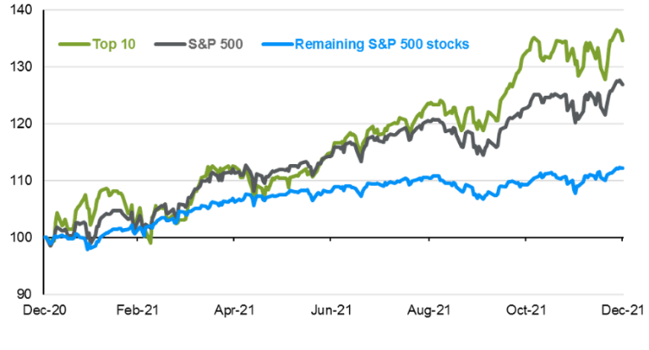
As of December 31, 2021, the 10 largest companies in the S&P 500 represent roughly 31% of the entire index. This is the highest percentage ever recorded, moving past the highs of the tech bubble in 2000. In addition, the current figure is noteworthy because the top 10 market cap nearly doubled from 16% representation since 2015. This rapid increase has come as companies like Apple, Amazon, and Tesla have grown significantly. Apple recently crossed $3 trillion in market cap. Not only is it the largest company in the world, but when compared to the economies of countries, its market cap ranks as the fifth largest economy behind the US, China, Japan, and Germany.
Source: JPMorgan Asset Management. What will happen to the top 10 S&P 500 companies in 2022?

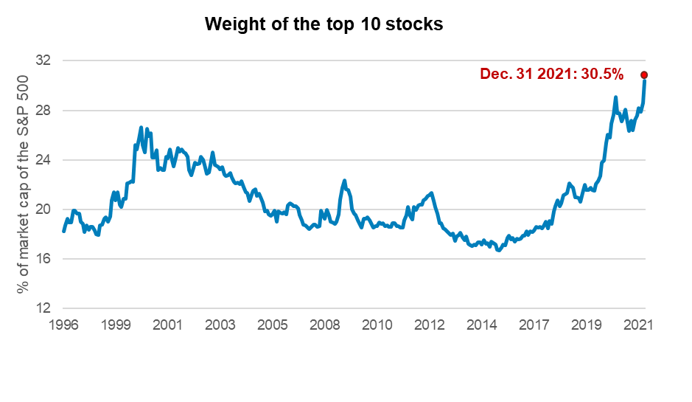
Source: FactSet. Top 10 stocks include: AAPL, MSFT, AMZN, FB, GOOGL, GOOG, TSLA, BRK.B, JPM, NVDA, UNH.
As select companies have grown in size, their impact on the index returns has also been outsized. In 2021, the top 10 names drove nearly two-thirds of the approximately 27% returns. In other words, the top 10 stocks contributed 19 percentage points, while the bottom 490 stocks contributed 8 percentage points. This outsized performance by a select few stocks has been a characteristic of the US equity market since the pandemic began. In 2020, we highlighted that just 6 technology stocks nicknamed FANAMA (Facebook, Apple, Netflix, Amazon, Microsoft, Alphabet) similarly drove roughly two-thirds of 2020 returns.
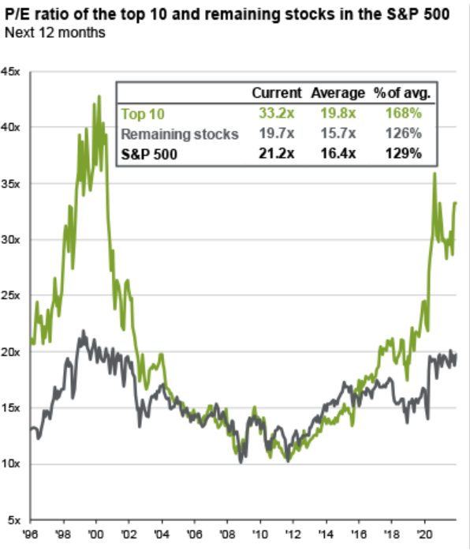
What does this mean for investors?
Without a look under the hood, it’s not always easy to tell when your stock portfolio is exposed to concentration risk. A deeper look shows that the uneven nature of stock returns has created a wide gap in how expensive these top 10 stocks have become relative to the rest of the market, as measured by the price to earnings ratio. The price to earnings ratio or P/E ratio is a common measure to assess the fairness of stock price. In general, a lower P/E ratio would mean the price is undervalued relative to future earnings and higher P/E means that that prices are overvalued. While this is an overly simplistic way of evaluating things, it does provide a reasonable gauge to assessing stock market valuations. While rising stock prices have made US stocks expensive relative to its own historical measure, the P/E of the top 10 stocks have increased at a much faster rate than the remaining stocks in the S&P 500. This dispersion in valuation may provide greater opportunity for active portfolio managers to be more selective in finding stocks that are reasonably valued with potential for better return prospects.
Source: JPMorgan Asset Management. Q1’22 Guide to the Markets.
In conclusion, while concentration within US equity markets remains a headwind for investors, the good news is that investors have options to address this hidden risk by choosing skilled active managers to find the less expensive parts of the equity market.

IMPORTANT INFORMATION
This is for informational purposes only, is not a solicitation, and should not be considered investment, legal or tax advice. The information in this report has been drawn from sources believed to be reliable, but its accuracy is not guaranteed, and is subject to change. Investors seeking more information should contact their financial advisor. Financial advisors may seek more information by contacting AssetMark at 800-664-5345.
Investing involves risk, including the possible loss of principal. Past performance does not guarantee future results. Asset allocation cannot eliminate the risk of fluctuating prices and uncertain returns. There is no guarantee that a diversified portfolio will outperform a non-diversified portfolio. No investment strategy, such as asset allocation, can guarantee a profit or protect against loss. Actual client results will vary based on investment selection, timing, market conditions, and tax situation. It is not possible to invest directly in an index.
Investments in equities, bonds, options, and other securities, whether held individually or through mutual funds and exchange traded funds, can decline significantly in response to adverse market conditions, company-specific events, changes in exchange rates, and domestic, international, economic, and political developments.
AssetMark, Inc. is an investment adviser registered with the U.S. Securities and Exchange Commission. AssetMark and third-party service providers are separate and unaffiliated companies. Each party is responsible for their own content and services.
©2022 AssetMark, Inc. All rights reserved.
103466 | C22-18375 | 01/2022 | EXP 01/31/2024

AssetMark, Inc.
1655 Grant Street
10th Floor
Concord, CA 94520-2445
800-664-5345

FactSet
Ned Davis Research Benchmark Review January 2022: Stocks climb ultimate wall of worry
S&P Dow Jones: https://www.spglobal.com/spdji/en/indices/equity/sp-500/#overview
https://www.morningstar.com/articles/1071605/4-charts-on-apples-3-trillion-market-cap
https://am.jpmorgan.com/us/en/asset-management/adv/insights/market-insights/market-updates/on-the-minds-of-investors/what-will-happen-to-the-top-10-sp-500-companies-in-2022/
FactSet. AssetMark quarter end insights Q4’20: What the heck happened in 2022?
JPMorgan Asset Management. Q1’22 Guide to the Markets.

