Volatility: The Painful Return to Normal
After a stellar and unusually calm year for stocks in 2021, so far 2022 might appear almost chaotic by comparison, with markets experiencing a sharp correction in January. A quick survey of history reveals that this type of recent volatility is actually quite normal, and that it was 2021’s lack of market turmoil that is truly the outlier. That said, January has been volatile, and investors are wondering how did we get here, and what should be expected going forward? While there is a myriad of reasons for markets to worry, such as Omicron impacting economic growth or ongoing supply chain disruptions, the key issue is the Federal Reserve’s (Fed) shift in policy. Investors appear concerned that the Fed will hike interest rates faster than previously expected. The S&P 500 is down 7.4%, small-cap stocks represented by the Russell 2000 index are down 9.4%, and the technology heavy Nasdaq index is down 11.4% for the year through market close on January 24th, 2022. Investors should moderate market return expectations and prepare for more normal pullbacks.
Are stocks doomed if interest rates rise?
Interest rate cuts occur when the economy is weak and interest rate hikes occur to cool a hot economy. Despite the Fed’s view that inflation will moderate from current high levels, the current level is higher than any other time in recent history. As such, the Fed is trying to dampen those inflationary pressures by taking their foot off the economic accelerator via higher short-term interest rates. Moreover, with the U.S economy having fully recovered from the pandemic losses and inflation well above average, it’s hard to justify a zero-interest rate policy when the economy is no longer in crisis.
History tells us that stocks have held up well when the Fed raises short-term rates, because this action is normally paired with a healthy economy. A growing economy supports corporate profit growth, which supports the stock market. According, to research by Wells Fargo Investment Institute, the S&P 500 index has risen in the 12 months prior to and the 12 months after the first-rate hike, with lower average returns after the initial interest rate hike. While stock returns typically moderate after the first hike, historically it has not spelled doom for stocks either.
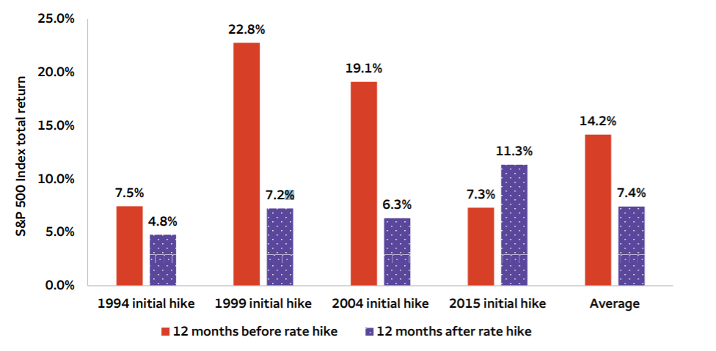
How Stocks Have Performed When the Fed Has Raised Rates
Source: Wells Fargo Investment Institute. How stocks have performed when the Fed raised rates

Corrections while painful, are normal
Another reason the recent volatility feels heightened is due to how unusually calm the markets have been coming out of the pandemic lows. In 2021, the S&P 500's biggest drawdown was 5.2%, when typically, the markets experience a 5% correction 2-3 times a year. Instead, the index hit 70 new all-time highs in 2021, second most on record after 77 in 1995 . However, according to JPMorgan Asset Management, since 1980 the S&P 500 has experienced an average intra-year decline of 14%. Despite the average intra-year decline of 14% markets ended in positive territory in 32 out of 42 years. Corrections or pullbacks are normal and healthy ways of keeping markets from getting overvalued.
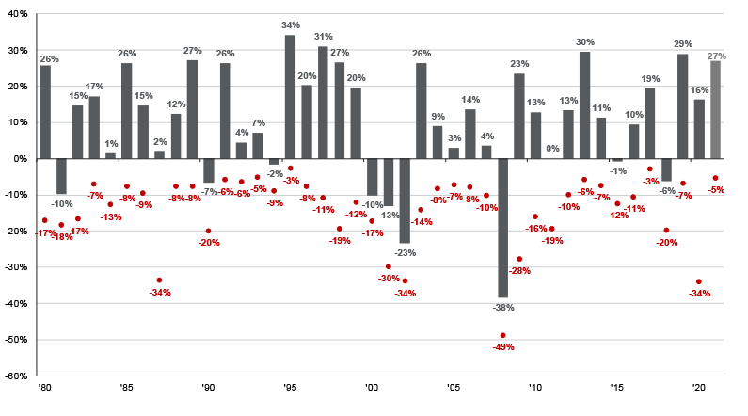
Annual Returns and Intra-Year Declines for S&P 500
Source: JPMorgan Asset Management. Guide to the Markets Q1 2021
Conclusion
While a shift in Fed policy often introduces volatility in markets, it does not necessarily forecast an imminent recession in the economy nor the death of stock markets. As investors, many of us have wanted a return to normal since the pandemic began. As expected, the markets are running ahead of the economy and the markets are experiencing a normal bout of volatility. Indeed, this is one of the key points discussed in our year-end commentary and is a reason why investors should moderate market return expectations and prepare for more normal pullbacks.

IMPORTANT INFORMATION
This is for informational purposes only, is not a solicitation, and should not be considered investment, legal or tax advice. The information in this report has been drawn from sources believed to be reliable, but its accuracy is not guaranteed, and is subject to change. Investors seeking more information should contact their financial advisor. Financial advisors may seek more information by contacting AssetMark at 800-664-5345.
Investing involves risk, including the possible loss of principal. Past performance does not guarantee future results. Asset allocation cannot eliminate the risk of fluctuating prices and uncertain returns. There is no guarantee that a diversified portfolio will outperform a non-diversified portfolio. No investment strategy, such as asset allocation, can guarantee a profit or protect against loss. Actual client results will vary based on investment selection, timing, market conditions, and tax situation. It is not possible to invest directly in an index. Indexes are unmanaged, do not incur management fees, costs and expenses and cannot be invested in directly. Index performance assumes the reinvestment of dividends.
Investments in equities, bonds, options, and other securities, whether held individually or through mutual funds and exchange traded funds, can decline significantly in response to adverse market conditions, company-specific events, changes in exchange rates, and domestic, international, economic, and political developments.
AssetMark, Inc. is an investment adviser registered with the U.S. Securities and Exchange Commission. AssetMark and third-party service providers are separate and unaffiliated companies. Each party is responsible for their own content and services.
©2022 AssetMark, Inc. All rights reserved.
103535 | C22-18417 | 01/2022 | EXP 01/31/2024

AssetMark, Inc.
1655 Grant Street
10th Floor
Concord, CA 94520-2445
800-664-5345

AssetMark, FactSet.
https://www08.wellsfargomedia.com/assets/pdf/personal/investing/investment-institute/chart_of_the_week_ADA.pdf
AssetMark, FactSet
NDR: Benchmark Review: Stocks climb ultimate wall of worry
https://am.jpmorgan.com/us/en/asset-management/adv/insights/market-insights/guide-to-the-markets/

