Is the 60/40 Portfolio Dead or Just Dazed?
Key Takeaways
- 2022 has dealt a blow to the 60/40 portfolio. While losses in a 60/40 portfolio are not unusual, losses in stocks and bonds simultaneously are unusual.
- Since 1928, with nearly 100 years of track record, the 60/40 portfolio has never had a negative return in any 10-year period.
- Diversification benefits of a 60/40 portfolio are not dead, even if they are not working right now. Today’s dislocations also offer opportunities for investors going forward.
2022 has been a tough year for both stocks and bonds. This synchronized selloff in stocks and bonds has dealt a blow to one of the most popular strategies for long-term investors: the 60/40 portfolio. This portfolio is a mix of 60% stocks and 40% bonds. The popularity behind the 60/40 portfolio stems from the key principle of diversification to seek growth potential from stocks while adding protection from conservative bonds for a more stable outcome over the long term.
Through the end of September 30, 2022, this portfolio using 60% in S&P 500 index and 40% in Bloomberg US Aggregate Bond Index, the most commonly used bond index, is down roughly 20%. With such a devasting year, we explore if this is normal, just how bad it can get, and what’s next for investors.
Is This Normal?
First, losses in the 60/40 portfolio are not unusual. Since 1976, looking at a one-year time period, about 14% of the time (once every seven years or so), this portfolio had negative returns.
However, what is noteworthy is that losses in stocks and bonds simultaneously are less common. While the 60/40 portfolio experiences losses roughly 14% of the time for the one-year period, losses in stocks and bonds for the same time period occurs only 0.4% of the time.
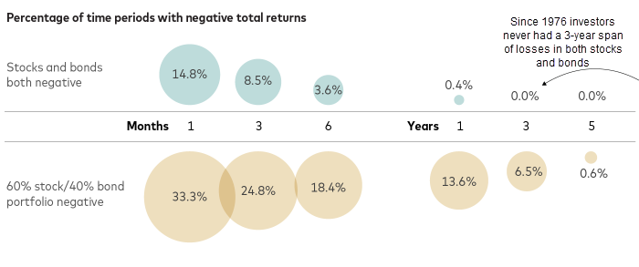Source: Vanguard. Data from Feb’76-Apr’22.
In fact, since 1976 investors have never encountered a three-year span of losses in both stocks and bonds even when the 60/40 portfolio saw losses 6.5% of the time for a three-year period. The reason is simple, generally, the losses are often driven by the higher allocation to stocks which are riskier.
Is This the Worst Year for the 60/40?
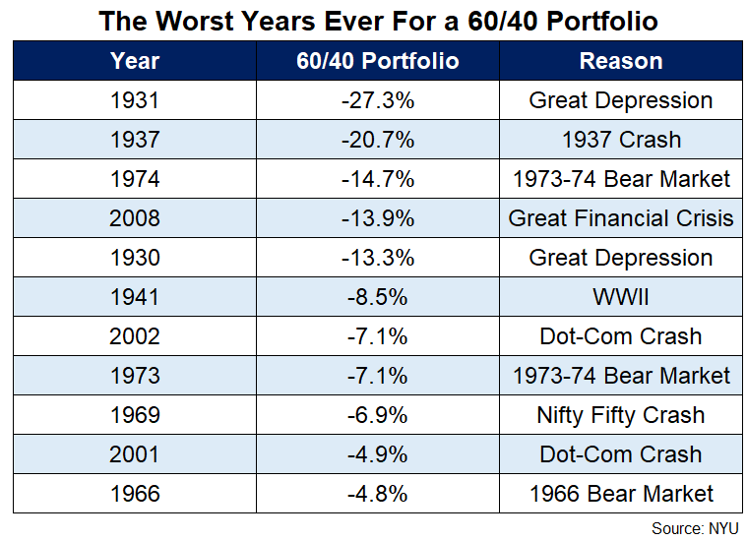
A look at the worst calendar years for the 60/40 portfolio shows if the year were to end as of September 30, 2022, the returns would mark the third worst in history, only after the worst of the Great Depression and the 1937 Crash. Clearly, that is not a prize any portfolio wants to win, especially when returns are compared to periods like the Great Depression.
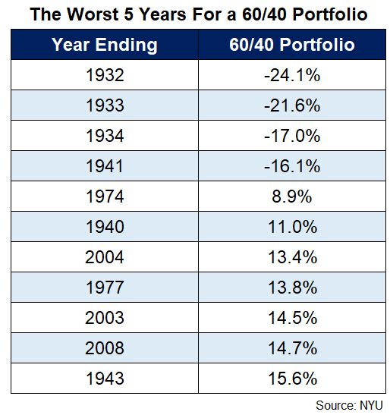
Once again, looking at the worst 5-year or 10-year periods provides some perspective and solace for the 60/40 portfolio investor. For the worst 5-years, outside of the 4-time periods during the Great Depression, there have been no instances where a 60/40 portfolio suffered losses over a five-year period. The news gets better as you look at the ten-year returns for 60/40 portfolio. In the nearly 100 years of data, which includes the Great Depression, World War II, the Great Inflation of the 1970s, and the Great Financial crisis of 2008, there has never been a time period with negative returns for the 60/40 portfolio over a 10-year period.

What Next for the 60/40 Portfolio?
First, diversification is not dead, even if it’s not working right now. In 2022, inflation has been the most important concern. The Fed’s effort to tame inflation drove interest rates sharply higher. This caused both stocks and bonds to fall sharply. Given the Fed’s action, negative returns for stocks are not surprising. Much of the pain in bonds stems from starting at near zero yields in 2021, which provided bond investors with no cushion from price hits as interest rates rose. Looking to the future, however, when the fear shifts from inflation to recession and growth, the traditional diversification benefits across stocks and bonds will come back into play.
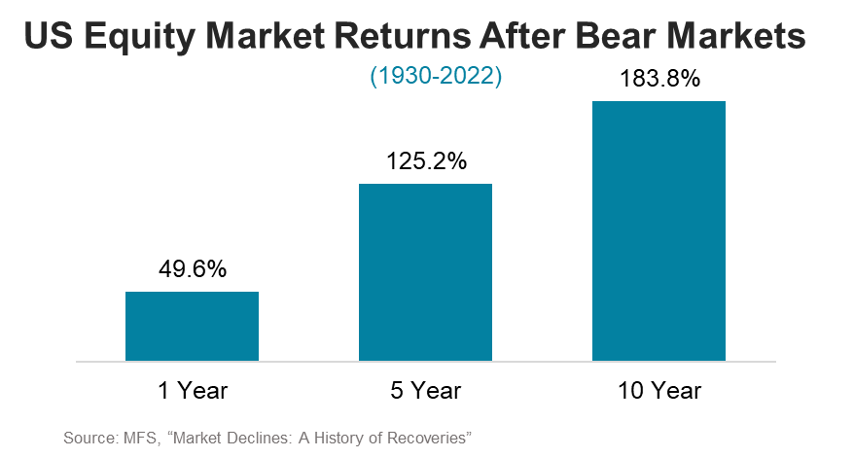
Second, the selloff in markets provides greater return potential over the long term. Historically, after an equity bear market (a drop of 20% or more), the subsequent 1-, 5- and 10-year cumulative returns for the equity markets have been strong.

Similarly, bond yields have improved dramatically too. The yield on the Bloomberg US Aggregate Bond Index, as of September 30, 2022, stood at 4.8%, a 3x gain from 1.6% a year ago. Rising interest rates have been a source of short-term pain this year, but today’s higher yields have significantly boosted the outlook for future fixed-income returns.
Conclusion
The challenges facing a 60/40 portfolio may continue to plague us for longer, but that does not mean the strategy is dead. The sharp selloff in stocks and rising yields in bonds have improved the potential for the long-term outlook for the traditional 60/40 portfolio. Finally, investors could seek opportunities to improve diversification through the inclusion of active management, as well as the inclusion of alternative strategies beyond traditional stocks and bonds. Challenging years like 2022 remind investors that diversification works over time, but not every time.

AssetMark, Inc.
1655 Grant Street
10th Floor
Concord, CA 94520-2445
800-664-5345
IMPORTANT INFORMATION
This is for informational purposes only, is not a solicitation, and should not be considered investment, legal or tax advice. The information in this report has been drawn from sources believed to be reliable, but its accuracy is not guaranteed, and is subject to change. Investors seeking more information should contact their financial advisor. Financial advisors may seek more information by contacting AssetMark at 800-664-5345.
Investing involves risk, including the possible loss of principal. Past performance does not guarantee future results. Asset allocation cannot eliminate the risk of fluctuating prices and uncertain returns. There is no guarantee that a diversified portfolio will outperform a non-diversified portfolio. No investment strategy, such as asset allocation, can guarantee a profit or protect against loss. Actual client results will vary based on investment selection, timing, market conditions, and tax situation. It is not possible to invest directly in an index. Indexes are unmanaged, do not incur management fees, costs and expenses and cannot be invested in directly. Index performance assumes the reinvestment of dividends.
Investments in equities, bonds, options, and other securities, whether held individually or through mutual funds and exchange traded funds, can decline significantly in response to adverse market conditions, company-specific events, changes in exchange rates, and domestic, international, economic, and political developments.
You agree not to redistribute the Information to recipients not authorized by AssetMark. You agree that the Providers are considered to be third-party beneficiaries of the Terms of Use.
AssetMark, Inc. is an investment adviser registered with the U.S. Securities and Exchange Commission. AssetMark and third-party service providers are separate and unaffiliated companies. Each party is responsible for their own content and services.
©2022 AssetMark, Inc. All rights reserved.
103329| C22- 19291| 10/2022 | EXP 10/31/2024

IMPORTANT INFORMATION
This is for informational purposes only, is not a solicitation, and should not be considered investment, legal or tax advice. The information in this report has been drawn from sources believed to be reliable, but its accuracy is not guaranteed, and is subject to change. Investors seeking more information should contact their financial advisor. Financial advisors may seek more information by contacting AssetMark at 800-664-5345.
Investing involves risk, including the possible loss of principal. Past performance does not guarantee future results. Asset allocation cannot eliminate the risk of fluctuating prices and uncertain returns. There is no guarantee that a diversified portfolio will outperform a non-diversified portfolio. No investment strategy, such as asset allocation, can guarantee a profit or protect against loss. Actual client results will vary based on investment selection, timing, market conditions, and tax situation. It is not possible to invest directly in an index. Indexes are unmanaged, do not incur management fees, costs and expenses and cannot be invested in directly. Index performance assumes the reinvestment of dividends.
Investments in equities, bonds, options, and other securities, whether held individually or through mutual funds and exchange traded funds, can decline significantly in response to adverse market conditions, company-specific events, changes in exchange rates, and domestic, international, economic, and political developments.
AssetMark, Inc. is an investment adviser registered with the U.S. Securities and Exchange Commission. AssetMark and third-party service providers are separate and unaffiliated companies. Each party is responsible for their own content and services.
©2022 AssetMark, Inc. All rights reserved.
103305 | C22-18578 | 05/2022 | EXP 05/31/2024

AssetMark, Inc.
1655 Grant Street
10th Floor
Concord, CA 94520-2445
800-664-5345

This edition focuses on the 60/40 portfolio, investors with longer time horizon may have a more aggressive mix while those closer to retirement may be more conservatively allocated.
FactSet
Vanguard. Like the phoenix, the 60/40 portfolio will rise again
Ibid
Ibid
60/40 constructed using S&P 500 and 10-Year Treasury
Ben Carlson. The Worst Years Ever For a 60/40 Portfolio
Ibid
MFS, “Market Declines: A History of Recoveries”.
FactSet

