The Worst Years for US Stocks
Stock market losses occur for various reasons. Sometimes they are driven by excessive market valuations after an extended bull market. In others, they may be due to external events, such as a war or a pandemic. A look back at the worst years for US stocks provides perspective on how long a selloff can last and shows that even the worst years come to an end.
The bad news:
- From 1928 - 2021, the S&P 500 had 25 negative years. In other words, 73% of the time stocks had positive returns.
- Of the 25 negative years since 1928, 11 of those were double-digit losses and mark the worst years.
- While rare, there have been eight times since 1928 of two consecutive years of negative returns. Rarer still, there have been three instances of three consecutive years of negative returns and only once, during the Great Depression, when stocks fell four years in a row.
The good news:
- The longer-term returns after the worst years have historically been strong. Historically, after the worst years, the average three-year historical return was +35%, while the average five-year return was 80%.
- While the results of the one-year period following the worst years are mixed, there was only one three-year period during the Great Depression with negative returns.
- Looking further out, every five-year period return following one of these worst years, saw positive returns.
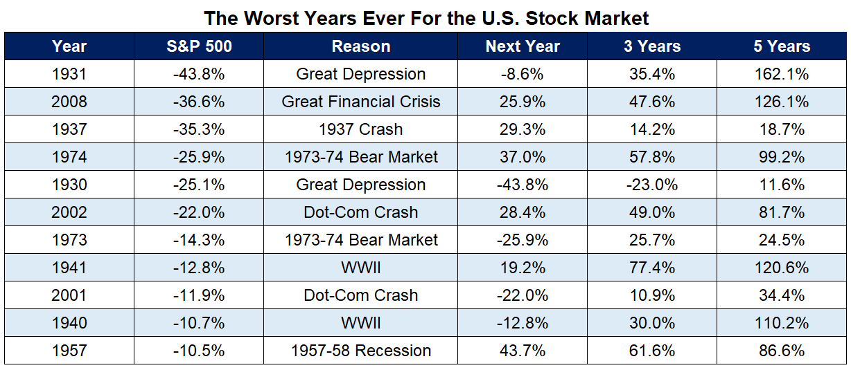

Source: Ben Carlson, A Wealth of Common Sense
Even after the worst years for stock markets, the markets have always bounced back. Investors who remain disciplined in a negative market are likely to avoid common pitfalls and potentially enjoy better times ahead. Historically, the longer you stay invested, the greater the possibility of meeting your long-term goals.
IMPORTANT INFORMATION
This is for informational purposes only, is not a solicitation, and should not be considered investment, legal or tax advice. The information in this report has been drawn from sources believed to be reliable, but its accuracy is not guaranteed, and is subject to change. Investors seeking more information should contact their financial advisor. Financial advisors may seek more information by contacting AssetMark at 800-664-5345.
Investing involves risk, including the possible loss of principal. Past performance does not guarantee future results. Asset allocation cannot eliminate the risk of fluctuating prices and uncertain returns. There is no guarantee that a diversified portfolio will outperform a non-diversified portfolio. No investment strategy, such as asset allocation, can guarantee a profit or protect against loss. Actual client results will vary based on investment selection, timing, market conditions, and tax situation. It is not possible to invest directly in an index. Indexes are unmanaged, do not incur management fees, costs and expenses and cannot be invested in directly. Index performance assumes the reinvestment of dividends.
Investments in equities, bonds, options, and other securities, whether held individually or through mutual funds and exchange traded funds, can decline significantly in response to adverse market conditions, company-specific events, changes in exchange rates, and domestic, international, economic, and political developments.
Bloomberg® and the referenced Bloomberg Index are service marks of Bloomberg Finance L.P. and its affiliates, (collectively, “Bloomberg”) and are used under license. Bloomberg does not approve or endorse this material, nor guarantees the accuracy or completeness of any information herein. Bloomberg and AssetMark, Inc. are separate and unaffiliated companies.
Please read the Terms of Use posted at www.ewealthmanager.com that govern the use of these materials and also be advised:
AssetMark uses financial market information (“Information”) from third-party providers (“Providers”) in reports (“Materials”). The Information includes, but is not limited to, financial market data, quotes, news, analyst opinions and research reports. The Materials are for informational purposes only, not a solicitation or for use in the creation/management/offering/sale of any financial instrument or product based thereon and should not be considered investment, legal or tax advice. The Information has been drawn from sources believed to be reliable, but its accuracy and timeliness is not guaranteed, and is subject to change. You agree that neither AssetMark nor the Providers are liable for the use of the Information.
You agree not to redistribute the Information to recipients not authorized by AssetMark. You agree that the Providers are considered to be third-party beneficiaries of the Terms of Use.
AssetMark, Inc. is an investment adviser registered with the U.S. Securities and Exchange Commission. AssetMark and third-party service providers are separate and unaffiliated companies. Each party is responsible for their own content and services.
©2022 AssetMark, Inc. All rights reserved.
104218 | C22-18881 | 06/2022 | EXP 06/30/2024

AssetMark, Inc.
1655 Grant Street
10th Floor
Concord, CA 94520-2445
800-664-5345
AssetMark, Inc.
1655 Grant Street
10th Floor
Concord, CA 94520-2445
800-664-5345

FactSet
https://awealthofcommonsense.com/2022/05/the-worst-years-ever-in-the-stock-market/
FactSet
https://awealthofcommonsense.com/2022/05/the-worst-years-ever-in-the-stock-market/

