Will High Inflation Last Forever?
Highlights:
- Inflation hit 9.1% in June—its highest level in four decades.¹
- The Fed raised interest rates in an effort to slow US growth and moderate inflation. Fed officials are signaling another 75 basis points (bps) hike at the July 26-27 meeting due to the latest inflation numbers.
- A lower inflation rate doesn’t require falling prices; it simply requires prices to not rise as fast as they did last year.
Milton Friedman famously declared that inflation is “always and everywhere a monetary phenomenon”. While it’s hard to disagree with a legendary economist, monetary economics don’t quite capture real life and how we’re feeling today. Inflation hurts all of us, and it can profoundly influence our expectations and behaviors. For many, inflation brings back 1970s-era memories of long lines at gas stations and ballooning mortgage rates. If inflation persists for too long, it can spur people to make panic or bulk purchases which can drive prices even higher. We haven’t seen this scenario play out yet because the US economy is slowing and reducing demand.
Will High Inflation Last Forever?
As a refresher, inflation is measured by the Consumer Price Index (CPI), which calculates the average monthly price that consumers pay for a basket of goods and services. As inflation recently increased 9.1% through June 2022, the largest 12-month increase since November 1981, let’s review the key components that drove the increase and assess if the category prices may rise or fall over the next 12 months. See the chart below for details.
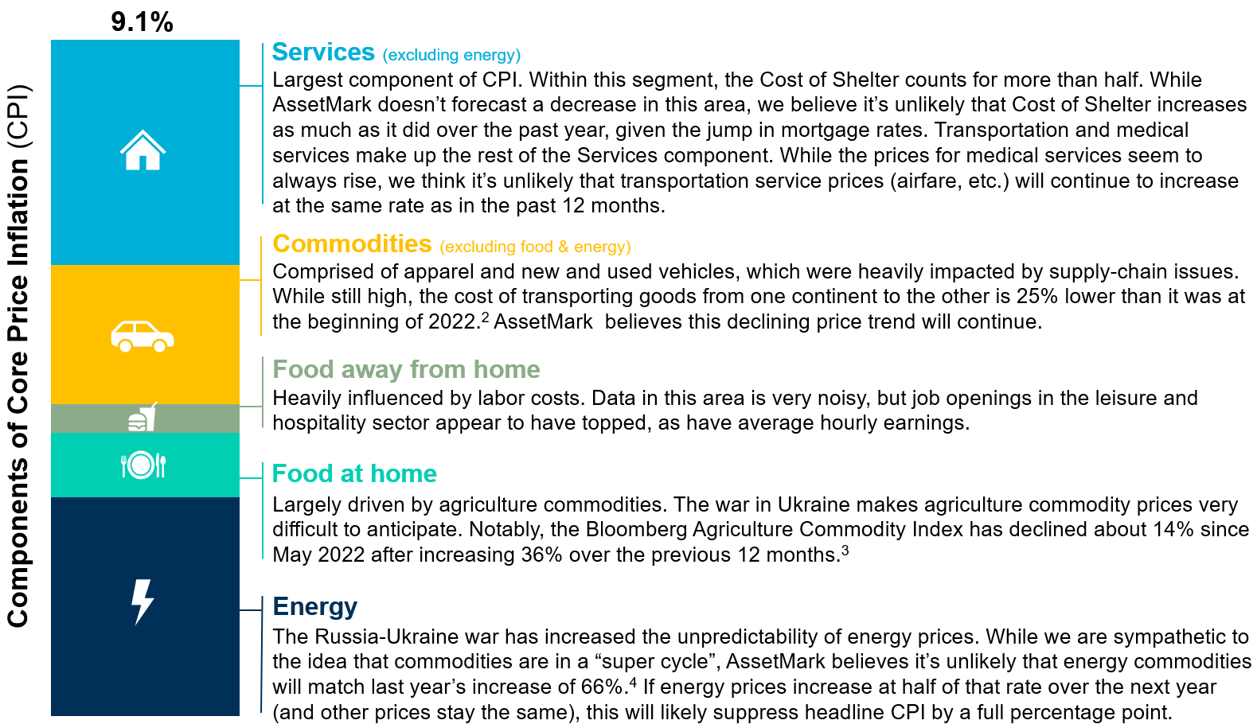
Slowing Down Inflation Doesn’t Mean Prices Will Be Lower
In an inflationary environment, higher prices eventually lead to lower growth, which contributes to lower prices, and ultimately, lower inflation. By recently raising interest rates to combat inflation, the Fed is accelerating the lower growth phase of the process. Does this mean prices will fall? Probably not, because slower inflation just means that prices don’t rise as fast as they did last year.

Sources:
- Bureau of Labor Statistics. Economic News Release – Consumer Price Index (CPI). July 13, 2022. https://www.bls.gov/news.release/cpi.nr0.htm
- Bloomberg
- Ibid.
- Ibid.

IMPORTANT INFORMATION
This is for informational purposes only, is not a solicitation, and should not be considered investment, legal or tax advice. The information in this report has been drawn from sources believed to be reliable, but its accuracy is not guaranteed, and is subject to change. Investors seeking more information should contact their financial advisor. Financial advisors may seek more information by contacting AssetMark at 800-664-5345.

Investing involves risk, including the possible loss of principal. Past performance does not guarantee future results. Asset allocation cannot eliminate the risk of fluctuating prices and uncertain returns. There is no guarantee that a diversified portfolio will outperform a non-diversified portfolio. No investment strategy, such as asset allocation, can guarantee a profit or protect against loss. Actual client results will vary based on investment selection, timing, market conditions, and tax situation. It is not possible to invest directly in an index. Indexes are unmanaged, do not incur management fees, costs and expenses and cannot be invested in directly. Index performance assumes the reinvestment of dividends.

Investments in equities, bonds, options, and other securities, whether held individually or through mutual funds and exchange traded funds, can decline significantly in response to adverse market conditions, company-specific events, changes in exchange rates, and domestic, international, economic, and political developments.
Bloomberg® and the referenced Bloomberg Index are service marks of Bloomberg Finance L.P. and its affiliates, (collectively, “Bloomberg”) and are used under license. Bloomberg does not approve or endorse this material, nor guarantees the accuracy or completeness of any information herein. Bloomberg and AssetMark, Inc. are separate and unaffiliated companies.

AssetMark, Inc. is an investment adviser registered with the U.S. Securities and Exchange Commission.

104403 | C22-19001 | 07/2022 | EXP 07/31/2024
AssetMark, Inc.
1655 Grant Street
10th Floor
Concord, CA 94520-2445
800-664-5345

