Revisiting Bonds: The Interest Rate Conundrum
The Federal Reserve’s recent attempt to tame inflation has resulted in a sharp decline in bond prices. The current situation is incredibly unique. Through May 31, 2022, core bonds, as represented by the Bloomberg US Aggregate index, have fallen over 10%⎯the largest fall coincident with a market selloff since at least 1962.
To better understand the complexity of the current situation, let’s start with why bond prices decline.
A bond purchase is similar to making a loan to a corporation or a government entity. A bond held till maturity pays interest (also known as a coupon) periodically and returns principal on the maturity date. Let’s assume the coupon rate of a bond is 3%. When interest rates rise, new bonds will be issued with a higher coupon rate, which means the old bond with the 3% coupon is now less desirable. For the old bond to be attractive to investors, it must be priced at a discount. This causes existing bond holders to see price declines when interest rates rise.
Is there a silver lining?
While the recent sharp rise in interest rates has resulted in steep price declines and significant losses, it has also provided a larger cushion for future investors. For example, the yield on the 2-year Treasury note rose from 0.14% a year ago to 2.55% as of May 31, 2022. In other words, an investor who purchases a 2-year Treasury note at the end of May 31, 2022, can expect to earn 2.55% of income.
The chart below illustrates how higher yields provide a greater cushion for bond investors against a future rise in rates. For example, interest rates would need to rise enough to push the yields above 3.87% for the 2-year bond to begin to lose money over the next 12 months. The hypothetical breakeven in the chart below represents the maximum amount yields can rise over the next 12 months before total returns (including both coupons and bond price drops) are negative. The cushion against future bond prices falling is greatest for shorter-term bonds where yield increases have been dramatic.

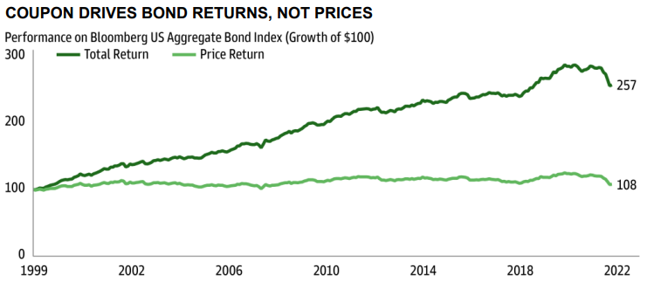
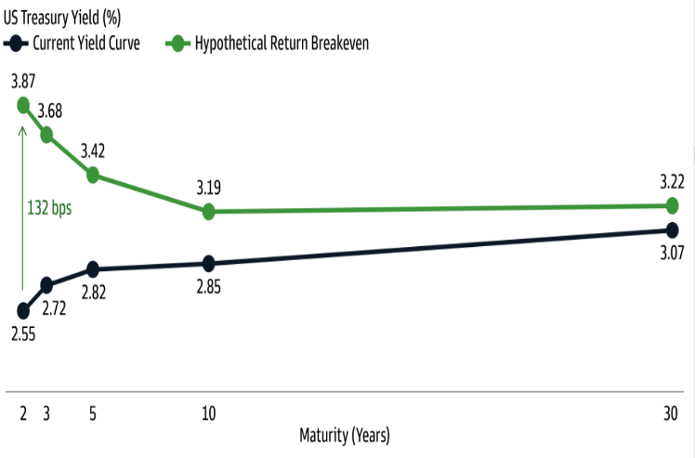
HIGHER YIELDS PROVIDE GREATER CUSHION

Source: Goldman Sachs Asset Management. As of May 31, 2022. Source: Goldman Sachs Asset Management. As of May 31, 2022.

Another reason the higher yield matters for long-term investors is because of its significance to total returns for bond investors. Total return for bonds is driven by coupon and price changes. Historically, the coupon for the commonly used US bond index, the Bloomberg US Aggregate Bond Index has been shown to be the primary driver of total return . Today’s higher yields relative to the start of 2022, offer a better buffer to interest rate volatility going forward.

To be clear, interest rate risk remains elevated, and the Fed may decide to hike rates more aggressively than expected. However, if history is any indication, the short-term hiccup in the bond market during a rising rate environment could pave the way for higher coupon payments and higher total returns over time.
IMPORTANT INFORMATION
This is for informational purposes only, is not a solicitation, and should not be considered investment, legal or tax advice. The information in this report has been drawn from sources believed to be reliable, but its accuracy is not guaranteed, and is subject to change. Investors seeking more information should contact their financial advisor. Financial advisors may seek more information by contacting AssetMark at 800-664-5345.

Investing involves risk, including the possible loss of principal. Past performance does not guarantee future results. Asset allocation cannot eliminate the risk of fluctuating prices and uncertain returns. There is no guarantee that a diversified portfolio will outperform a non-diversified portfolio. No investment strategy, such as asset allocation, can guarantee a profit or protect against loss. Actual client results will vary based on investment selection, timing, market conditions, and tax situation. It is not possible to invest directly in an index. Indexes are unmanaged, do not incur management fees, costs and expenses and cannot be invested in directly. Index performance assumes the reinvestment of dividends.

Investments in equities, bonds, options, and other securities, whether held individually or through mutual funds and exchange traded funds, can decline significantly in response to adverse market conditions, company-specific events, changes in exchange rates, and domestic, international, economic, and political developments.

Please read the Terms of Use posted at www.ewealthmanager.com that govern the use of these materials and also be advised:

AssetMark uses financial market information (“Information”) from third-party providers (“Providers”) in reports (“Materials”). The Information includes, but is not limited to, financial market data, quotes, news, analyst opinions and research reports. The Materials are for informational purposes only, not a solicitation or for use in the creation/management/offering/sale of any financial instrument or product based thereon and should not be considered investment, legal or tax advice. The Information has been drawn from sources believed to be reliable, but its accuracy and timeliness is not guaranteed, and is subject to change. You agree that neither AssetMark nor the Providers are liable for the use of the Information.

You agree not to redistribute the Information to recipients not authorized by AssetMark. You agree that the Providers are considered to be third-party beneficiaries of the Terms of Use.

AssetMark, Inc. is an investment adviser registered with the U.S. Securities and Exchange Commission. AssetMark Investment Management, a division of AssetMark, Inc., includes AssetMark, Savos, and Aris strategies. AssetMark and third-party service providers are separate and unaffiliated companies. Each party is responsible for their own content and services.
©2022 AssetMark, Inc. All rights reserved.
104342 | C22-18961 | 06/2022 | EXP 06/30/2024

AssetMark, Inc.
1655 Grant Street
10th Floor
Concord, CA 94520-2445
800-664-5345

Beaumont Capital Management. Staying the Course in Turbulent Markets. May 2022.
FactSet.
Goldman Sachs Asset Management. Change in Yield…Change in Fortune. May 2022.
The breakeven level is calculated by dividing the yield of each maturity by the bond’s respective duration. Duration is the measure of interest rate sensitivity for each bond and measures the drop in price for each one percent increase in yields.
Goldman Sachs Asset Management. Market Pulse. June 2022.

