Three Takeaways from 2022
Key Takeaways

- 2022 was an exceptionally bad year as inflation and higher interest rates wreaked havoc on markets.
- 2022 is the only time in history where stocks and bonds each fell by more than 10% and even traditional inflation hedges failed to protect portfolios.
- Looking ahead to 2023, the singular focus on inflation will likely shift to growth and likely bringing new surprises for investors.

Last year was an exceptional year, and not in a good way. There was no shortage of worries during the year from COVID-19, the Ukraine war, and the most central story of all: inflation and interest rates. In this edition of On the Mark, we identify the impact of inflation on markets and whether investors should expect more of the same or changes in 2023.
Stocks and bonds fell 10% for the first time on record
In 2022, the Federal Reserve (Fed) switched its narrative from transitory inflation to one committed to taming the inflation beast. The Fed raised interest rates seven times from 0.0% to 4.25-4.5% in merely 10 months. This surge in interest rates hurt both stocks and bonds. Stocks, as represented by the S&P 500 index, fell 18.1%, its worst year since 2008 and the sixth worst on record. Meanwhile, bonds, as represented by the Bloomberg US Aggregate index, had its worst year since the inception of the index in 1976, falling by 13.1%.
Losses in stocks are not new. Losses within bonds are less common but also have occurred previously. What made 2022 unique is how sharply stocks and bonds fell simultaneously. Last year was only the sixth time since 1926 that both the S&P 500 and Bloomberg US Aggregate declined. What’s truly remarkable is that it was the only time in history where both stocks and bonds each fell by more than 10%, as seen in the below chart.
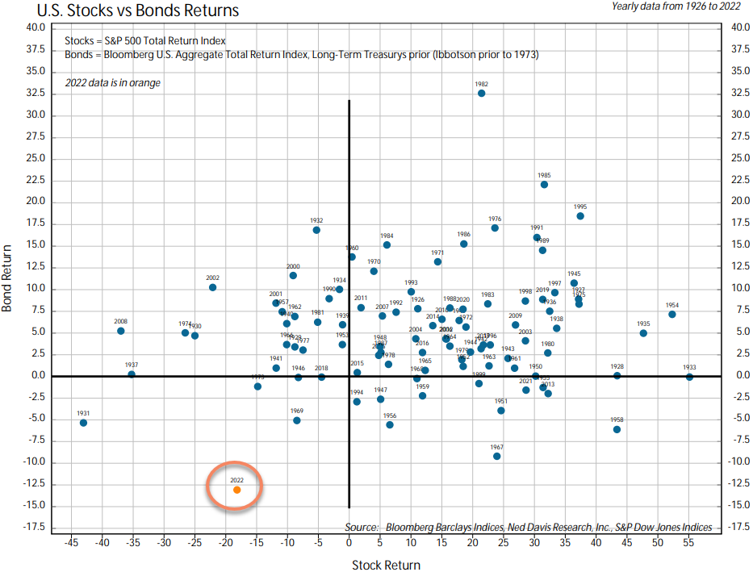
Source: Ned Davis Research. The 22 charts of 2022.
Boring was beautiful
While it was a hellish year for stocks, not all stocks fared the same. Over the past decade, fast-growing technology companies dominated returns when compared to those of more “boring” companies. That trend reversed course sharply in 2022 as investors were more focused on companies that made goods and have shown resiliency through varied economic cycles. The Nasdaq index, often synonymous with technology stocks, fell 32.5%, while the blue-chip stocks listed on the Dow index fell 6.9%, marking a difference of nearly 26%. It’s not that technological innovation is no longer valuable, but many of these companies were priced for perfection, and higher interest rates called into question earnings potential for many of these companies that were still years away from profitability.

Source: FactSet.
Traditional inflation hedges did not work either
Last year wasn’t challenging for only stocks and bonds. It also was a surprisingly challenging year for investments that were considered inflation hedges. Real estate, gold, and even bonds aimed at protecting against inflation, known as Treasury Inflation-Protected Securities (TIPS), all lost money in 2022. Even claims of cryptocurrency as an inflation hedge proved false. Bitcoin was down 75% from its peak toward the end of 2021. Except for commodities, there was no place for investors to hide.

Looking ahead to 2023
In 2022, the only thing that mattered to markets was inflation and the Fed’s focus on taming the inflation beast. This singular focus will shift in 2023 from inflation to growth since inflation has likely peaked and is falling, and the economy is slowing.

For riskier investments like stocks, even if the economy avoids an official recession, profit growth for companies likely will slow in 2023. Additionally, stock investors probably will become more focused on which companies can better weather that slowdown, a continuation of the trend we saw in 2022. However, while caution is warranted, economic uncertainties should not be used as a market timing tool. Markets are forward-looking and will likely bottom before the worst of the economic news is over.

Bonds, on the other hand, are unlikely to repeat the carnage of 2022. Higher starting yields should provide a better buffer from additional rate hikes. In fact, investors finally have reasonably attractive opportunities within bonds as they wade through continued uncertainty.

Finally, 2022 was a reminder of the importance of having a well-thought-out financial plan. It is a reminder that no matter how good or bad any single year proves to be, it should not derail one’s investment goal. Investing is a multi-year process and should accommodate even an exceptionally bad year. To that end, good riddance to 2022. Be glad it’s behind us.
Source: FactSet.

Important Information
This is for informational purposes only, is not a solicitation, and should not be considered investment, legal or tax advice. The information in this report has been drawn from sources believed to be reliable, but its accuracy is not guaranteed, and is subject to change. Investors seeking more information should contact their financial advisor. Financial advisors may seek more information by contacting AssetMark at 800-664-5345.

Investing involves risk, including the possible loss of principal. Past performance does not guarantee future results. Asset allocation cannot eliminate the risk of fluctuating prices and uncertain returns. There is no guarantee that a diversified portfolio will outperform a non-diversified portfolio. No investment strategy, such as asset allocation, can guarantee a profit or protect against loss. Actual client results will vary based on investment selection, timing, market conditions, and tax situation. It is not possible to invest directly in an index. Indexes are unmanaged, do not incur management fees, costs and expenses and cannot be invested in directly. Index performance assumes the reinvestment of dividends.

Investments in equities, bonds, options, and other securities, whether held individually or through mutual funds and exchange-traded funds, can decline significantly in response to adverse market conditions, company-specific events, changes in exchange rates, and domestic, international, economic, and political developments.
Bloomberg® and the referenced Bloomberg Index are service marks of Bloomberg Finance L.P. and its affiliates, (collectively, “Bloomberg”) and are used under license. Bloomberg does not approve or endorse this material, nor guarantees the accuracy or completeness of any information herein. Bloomberg and AssetMark, Inc. are separate and unaffiliated companies.

AssetMark, Inc. is an investment adviser registered with the U.S. Securities and Exchange Commission.
©2023 AssetMark, Inc. All rights reserved.
105189 | C23-19534 | 1/2023 | EXP 1/31/2025
AssetMark, Inc.
1655 Grant Street
10th Floor
Concord, CA 94520-2445
800-664-5345
For general public use.

FactSet
Gold represented by Bloomberg Sub Gold; Real Estate represented by S&P 1500 Equity Real Estate Investment Trusts
Coindesk

