The Path of Inflation – It’s All About That Base
Key Takeaway

- Whether it's the price of bread, gasoline, or rent, we all feel inflation. As consumers, we often feel inflation differently than the Fed measures inflation. In this month's On The Mark, we explore three aspects of inflation – price change versus price level, current inflation hot spots, and the base effect. The key takeaway is inflation finally appears to be falling.

Change, Not Level

This is a great example of how economists think differently than most people. Economists typically measure inflation by taking the price of a good (or service) on one date and comparing that to the price of the same good (or service) on another date. This price comparison is typically expressed as a percent change. For example, if the price of gasoline on January 1 was $3.00 per gallon, and it increased to $4.00 per gallon by January 31, the price inflation of gasoline during January would be +33.3%. Importantly, if the price of gasoline stays at $4.00 per gallon for the rest of the year, the price inflation of gasoline from February to December would be 0%. This may not be intuitive to most people, but the price of a good does not have to decrease for inflation to fall; it just needs to stop rising as quickly as it has risen in the past.
Inflation Hot Spots

Given that method of measuring inflation, where do we see rapid price increases? The chart on the next page shows the monthly percent changes in the goods and services comprising the "Core" Consumer Price Index (CPI) from January 2021 to October 2022. The Core CPI is one of the Fed's main measures of inflation in determining monetary policy. Areas of above-average inflation are highlighted in red, and areas of below-average inflation are highlighted in green.

The category in which we continue to see high inflation is in the "Shelter" component of CPI, which attempts to measure how much people are paying for shelter in the form of rent or a proxy for rent. Both shelter components tend to move slowly and often lag price changes in the real economy. For example, the average rent for a two-bedroom apartment fell by -0.4% during November². However, because rental agreements typically last for 6 or 12 months, most renters have not been able to reduce their shelter expense. Similarly, the jump in mortgage rates has led to substantial declines in many real estate markets. We estimate it will take 6 to 12 months before those reductions are reflected in the CPI.

"Core" CPI – Monthly Percent Changes in Price from January 2021 to October 2022¹

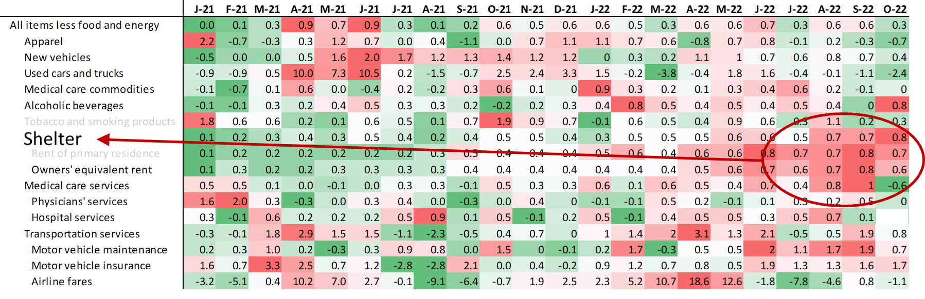

The Base Effect

Lastly, we want to point out that inflation is most often quoted on a year-over-year percentage change basis. Using a rolling 12-month measurement means what is "dropping off" of the rolling period is just as important as what is getting "added on.” Looking at the historical pattern of CPI in the chart below, we experienced very steep price increases from November 2021 to June 2022, with monthly changes averaging +0.8% (an annualized rate of +10%). Since June 2022 (through October 2022), monthly changes have dropped to +0.2% (annualized rate of +3%). As those unusually high months from November 2021 to June 2022 drop out of the 12-month window, year-over-year CPI measures will start to drop precipitously.
"Headline" CPI – The Base Effect
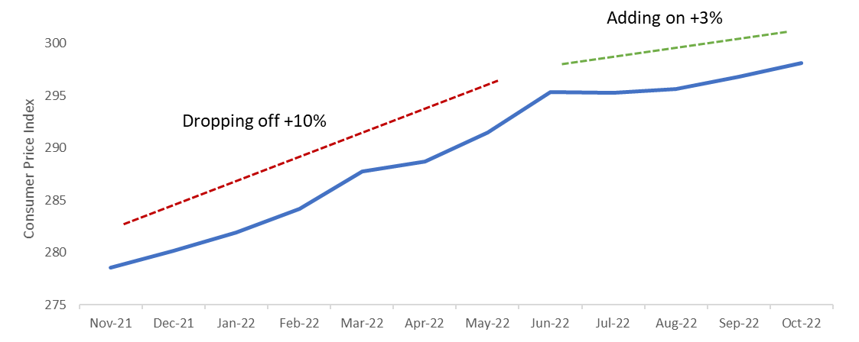
Clearly, declining year-over-year CPI readings due solely to the base effect does not benefit consumers. But this highlights that measuring inflation can be challenging, imprecise, and sometimes controversial. One thing I think we can all agree on is that 7.1% inflation is far too high. Thankfully, it looks like the worst is behind us.

Sources:
- US Bureau of Labor Statistics
- Zumper National Rent Report November 2022
IMPORTANT INFORMATION
This is for informational purposes only, is not a solicitation, and should not be considered investment, legal or tax advice. The information in this report has been drawn from sources believed to be reliable, but its accuracy is not guaranteed, and is subject to change. Investors seeking more information should contact their financial advisor. Financial advisors may seek more information by contacting AssetMark at 800-664-5345.

Investing involves risk, including the possible loss of principal. Past performance does not guarantee future results. Asset allocation cannot eliminate the risk of fluctuating prices and uncertain returns. There is no guarantee that a diversified portfolio will outperform a non-diversified portfolio. No investment strategy, such as asset allocation, can guarantee a profit or protect against loss. Actual client results will vary based on investment selection, timing, market conditions, and tax situation. It is not possible to invest directly in an index. Indexes are unmanaged, do not incur management fees, costs and expenses and cannot be invested in directly. Index performance assumes the reinvestment of dividends.

Investments in equities, bonds, options, and other securities, whether held individually or through mutual funds and exchange traded funds, can decline significantly in response to adverse market conditions, company-specific events, changes in exchange rates, and domestic, international, economic, and political developments.
Bloomberg® and the referenced Bloomberg Index are service marks of Bloomberg Finance L.P. and its affiliates, (collectively, “Bloomberg”) and are used under license. Bloomberg does not approve or endorse this material, nor guarantees the accuracy or completeness of any information herein. Bloomberg and AssetMark, Inc. are separate and unaffiliated companies.

AssetMark, Inc. is an investment adviser registered with the U.S. Securities and Exchange Commission.

##### | C##-#### | 07/2022 | EXP 07/31/2024
AssetMark, Inc.
1655 Grant Street
10th Floor
Concord, CA 94520-2445
800-664-5345

Important Information
This is for informational purposes only, is not a solicitation, and should not be considered investment, legal or tax advice. The information in this report has been drawn from sources believed to be reliable, but its accuracy is not guaranteed, and is subject to change. Investors seeking more information should contact their financial advisor. Financial advisors may seek more information by contacting AssetMark at 800-664-5345.

Investing involves risk, including the possible loss of principal. Past performance does not guarantee future results. Asset allocation cannot eliminate the risk of fluctuating prices and uncertain returns. There is no guarantee that a diversified portfolio will outperform a non-diversified portfolio. No investment strategy, such as asset allocation, can guarantee a profit or protect against loss. Actual client results will vary based on investment selection, timing, market conditions, and tax situation. It is not possible to invest directly in an index. Indexes are unmanaged, do not incur management fees, costs and expenses and cannot be invested in directly. Index performance assumes the reinvestment of dividends.

Investments in equities, bonds, options, and other securities, whether held individually or through mutual funds and exchange traded funds, can decline significantly in response to adverse market conditions, company-specific events, changes in exchange rates, and domestic, international, economic, and political developments.
Bloomberg® and the referenced Bloomberg Index are service marks of Bloomberg Finance L.P. and its affiliates, (collectively, “Bloomberg”) and are used under license. Bloomberg does not approve or endorse this material, nor guarantees the accuracy or completeness of any information herein. Bloomberg and AssetMark, Inc. are separate and unaffiliated companies.

AssetMark, Inc. is an investment adviser registered with the U.S. Securities and Exchange Commission.
©2022 AssetMark, Inc. All rights reserved.
105082 | C22- 19447 | 12/2022 | EXP 12/31/2024
AssetMark, Inc.
1655 Grant Street
10th Floor
Concord, CA 94520-2445
800-664-5345
For financial advisor use with advisory clients.

