Defend with an Inflation Buffer

With US inflation experiencing record highs and financial markets in correction territory, investors and their portfolios are being stress tested for the first time since the pandemic-induced drawdown of March 2020. With some components of inflation slowing in terms of price trends, others are starting to pick up which likely means that inflation will remain higher for longer. This environment offers no shortage of challenges and it could be time to consider your defensive playbook to help buffer inflation.
Inflation Beneficiaries
Asset classes respond differently to inflation and those experiences can differ substantially based on the level of inflation currently in action. Commodities and gold have been standouts in terms of benefiting from higher inflation, and have outperformed equities and bonds on a real return basis when inflation is above four percent. Looking at the last inflationary period of the 2000s, there were additional components that helped during times of higher inflation. The chart below shows how commodities and gold can be complemented with natural resources, infrastructure, or REITs to help create an inflation buffer. Natural resource miners, for example, benefit from the inflation-elevated prices that vehicle manufacturers are willing to pay for nickel and copper to keep up with the surging demand for electric vehicles.
Average 12-month real return when CPI is above certain levels (2003 – 2007)¹
Sensitivities and Interactions
Knowing how asset classes perform during levels of higher inflation is only half the battle. Knowing how sensitive they are to changes in inflation and how they interact or correlate with other asset classes and the traditional balanced portfolio is critical.
Asset class sensitivities to inflation and correlation to a Global 60/40 portfolio (Nov 2001 – Jun 2021)²
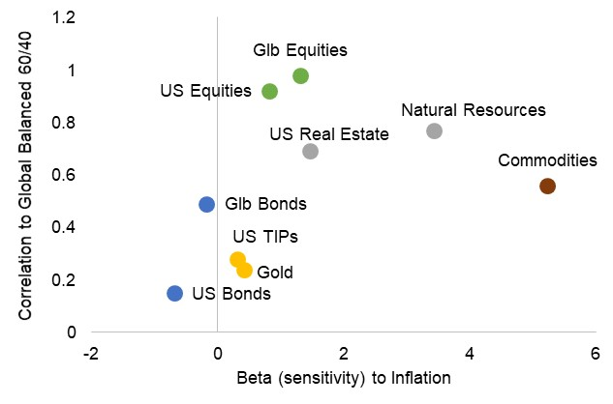
Equity complements
Bond complements
The chart above shows that commodities have the greatest sensitivity to inflation and are a good addition to a portfolio, but it’s only part of the story as they don’t clearly complement just equities or just bonds. REITs and natural resources complement equity exposure since they have similar characteristics but provide higher sensitivity to inflation. Inflation is a nemesis to bonds as seen by their negative beta. Alternatively, Treasury Inflation-Protected Securities (TIPS) and gold provide a similar low-correlation experience to help with risk management in addition to typically faring better during inflationary environments.
Portfolio construction 101 tells us to diversify assets to help manage overall portfolio risk. The same applies to building an inflation buffer. It’s essential to think about having a broad mix of investments, pinpointing the right areas to diversify into while building in some defense into the portfolio to enhance your results over the short and long term.

Sources:
- VanEck, “Still Early Innings for Inflation”, March 2022
IMPORTANT INFORMATION
This is for informational purposes only, is not a solicitation, and should not be considered investment, legal or tax advice. The information in this report has been drawn from sources believed to be reliable, but its accuracy is not guaranteed, and is subject to change. Investors seeking more information should contact their financial advisor. Financial advisors may seek more information by contacting AssetMark at 800-664-5345.

Investing involves risk, including the possible loss of principal. Past performance does not guarantee future results. Asset allocation cannot eliminate the risk of fluctuating prices and uncertain returns. There is no guarantee that a diversified portfolio will outperform a non-diversified portfolio. No investment strategy, such as asset allocation, can guarantee a profit or protect against loss. Actual client results will vary based on investment selection, timing, market conditions, and tax situation. It is not possible to invest directly in an index. Indexes are unmanaged, do not incur management fees, costs and expenses and cannot be invested in directly. Index performance assumes the reinvestment of dividends.

Investments in equities, bonds, options, and other securities, whether held individually or through mutual funds and exchange traded funds, can decline significantly in response to adverse market conditions, company-specific events, changes in exchange rates, and domestic, international, economic, and political developments.
Bloomberg® and the referenced Bloomberg Index are service marks of Bloomberg Finance L.P. and its affiliates, (collectively, “Bloomberg”) and are used under license. Bloomberg does not approve or endorse this material, nor guarantees the accuracy or completeness of any information herein. Bloomberg and AssetMark, Inc. are separate and unaffiliated companies.

AssetMark, Inc. is an investment adviser registered with the U.S. Securities and Exchange Commission.

##### | C##-#### | 07/2022 | EXP 07/31/2024
AssetMark, Inc.
1655 Grant Street
10th Floor
Concord, CA 94520-2445
800-664-5345
- AssetMark, Zephyr Style Advisor

IMPORTANT INFORMATION
This is for informational purposes only, is not a solicitation, and should not be considered investment, legal or tax advice. The information in this report has been drawn from sources believed to be reliable, but its accuracy is not guaranteed, and is subject to change. Investors seeking more information should contact their financial advisor. Financial advisors may seek more information by contacting AssetMark at 800-664-5345.

Investing involves risk, including the possible loss of principal. Past performance does not guarantee future results. Asset allocation cannot eliminate the risk of fluctuating prices and uncertain returns. There is no guarantee that a diversified portfolio will outperform a non-diversified portfolio. No investment strategy, such as asset allocation, can guarantee a profit or protect against loss. Actual client results will vary based on investment selection, timing, market conditions, and tax situation. It is not possible to invest directly in an index. Indexes are unmanaged, do not incur management fees, costs and expenses and cannot be invested in directly. Index performance assumes the reinvestment of dividends.

Investments in equities, bonds, options, and other securities, whether held individually or through mutual funds and exchange traded funds, can decline significantly in response to adverse market conditions, company-specific events, changes in exchange rates, and domestic, international, economic, and political developments.
Bloomberg® and the referenced Bloomberg Index are service marks of Bloomberg Finance L.P. and its affiliates, (collectively, “Bloomberg”) and are used under license. Bloomberg does not approve or endorse this material, nor guarantees the accuracy or completeness of any information herein. Bloomberg and AssetMark, Inc. are separate and unaffiliated companies.

AssetMark, Inc. is an investment adviser registered with the U.S. Securities and Exchange Commission.

104530 | C22-19072 | 08/2022 | EXP 08/31/2024
AssetMark, Inc.
1655 Grant Street
10th Floor
Concord, CA 94520-2445
800-664-5345

