3 Actions to Consider When Volatility Strikes
When volatility strikes and stock markets decline, it can rattle even the most experienced investors. As behavioral science tells us, the pain of an investment loss is felt more keenly than the enjoyment of an investment gain. The urge to soothe the sting of short-term losses can lead to hasty decision-making that could be costly in the long run. Staying invested and focusing on the things you can control may be your best bet during challenging markets. Here are three actions you can consider in the short term to enhance your long-term investment approach.
- Rebalance
Stocks tend to outperform bonds over the long run which can push a portfolio’s stock and bond ranges out of bounds. When markets get choppy, it can be a great time to review your portfolio and see if it needs rebalancing. This is also one of the best tools an investor can use to “buy low and sell high” in a disciplined way without running the risk of trying to time markets. The practice of rebalancing entails trimming portfolio positions that have outperformed and reinvesting the proceeds into areas that have underperformed. In the chart below, we show that over the long term, a portfolio that is rebalanced annually (light blue bar) can experience better performance and maintain risk than a portfolio that is not rebalanced (dark blue bar).

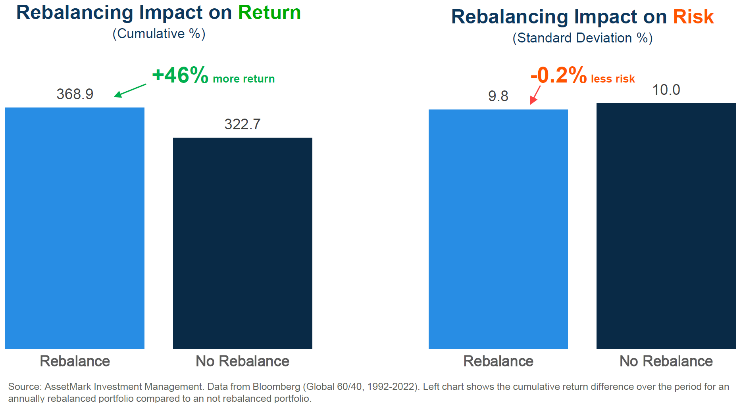

- Lean in
Opportunities can be found in most market cycles, down markets included. In the chart below (on the left), you can see that returns often rise in the one-year, three-year, and five-year periods following a bear market, particularly if you’re not confronting a severe recession such as the 2007-2008 Financial Crisis. Furthermore, leaning in during a drawdown by increasing stock positions may make sense for investors with longer time horizons. In the chart below (on the right), you can see that increasing the stock allocation of a 60/40 portfolio by ten percent can boost returns.
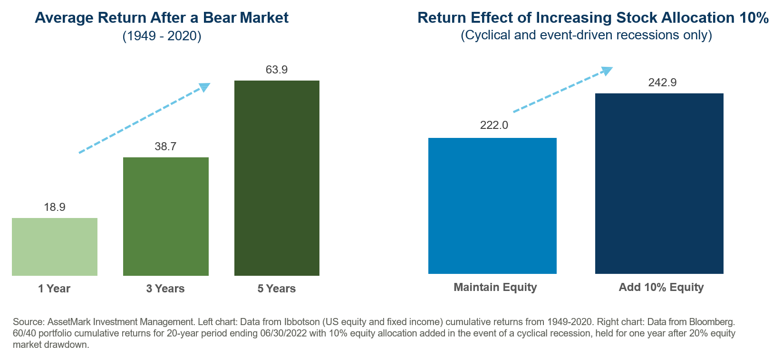
- Diversify
For investors thinking about pulling out of the market and moving to cash during a market decline, consider shifting to diversifying positions instead. Diversifying positions (or alternative investments) typically have better long-term return expectations than cash and can provide valuable diversification benefits. One such example is managed futures, an equity alternative investment style that can buy and sell stocks, bonds, currencies, and commodities. Unlike traditional stock and bond investments, managed futures can take advantage of negative market trends by selling investments in a variety of different asset classes and providing potential positive returns during declines while improving diversification. Adding alternative investments like managed futures will not eliminate negative returns for portfolios but can potentially reduce losses. For example, in the chart below, adding a 10% allocation to managed futures can lessen the impact of a drawdown by 5.2%.
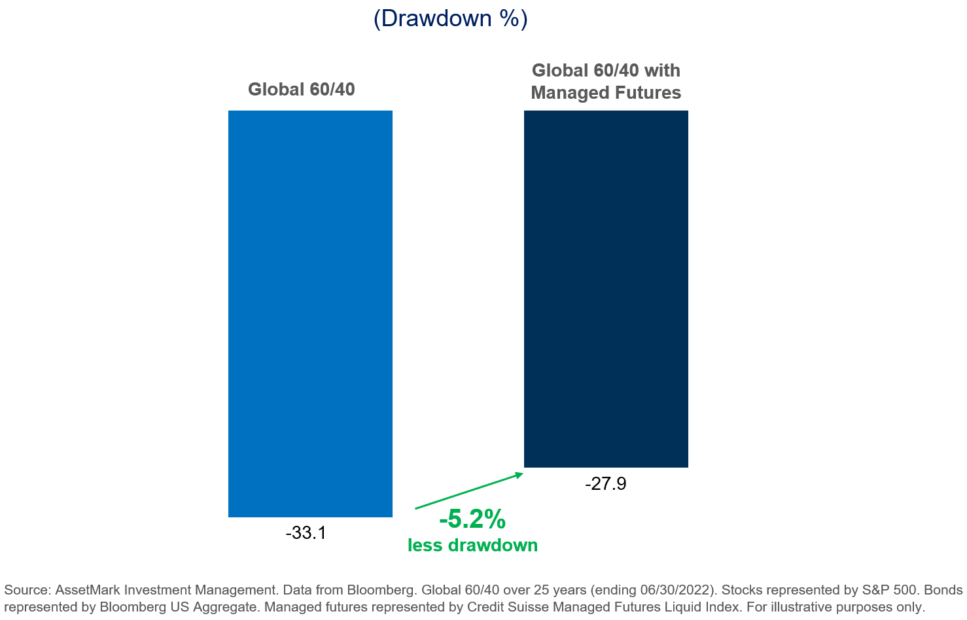

Portfolio losses are painful for everyone; however, market drawdowns can provide opportunities to strengthen portfolios by rebalancing (all investors), leaning in (aggressive investors or those with longer time horizons), and diversifying (all investors, particularly nervous investors).
IMPORTANT INFORMATION
This is for informational purposes only, is not a solicitation, and should not be considered investment, legal or tax advice. The information in this report has been drawn from sources believed to be reliable, but its accuracy is not guaranteed, and is subject to change. Investors seeking more information should contact their financial advisor. Financial advisors may seek more information by contacting AssetMark at 800-664-5345.

Investing involves risk, including the possible loss of principal. Past performance does not guarantee future results. Asset allocation cannot eliminate the risk of fluctuating prices and uncertain returns. There is no guarantee that a diversified portfolio will outperform a non-diversified portfolio. No investment strategy, such as asset allocation, can guarantee a profit or protect against loss. Actual client results will vary based on investment selection, timing, market conditions, and tax situation. It is not possible to invest directly in an index. Indexes are unmanaged, do not incur management fees, costs and expenses and cannot be invested in directly. Index performance assumes the reinvestment of dividends.

Investments in equities, bonds, options, and other securities, whether held individually or through mutual funds and exchange traded funds, can decline significantly in response to adverse market conditions, company-specific events, changes in exchange rates, and domestic, international, economic, and political developments.
Bloomberg® and the referenced Bloomberg Index are service marks of Bloomberg Finance L.P. and its affiliates, (collectively, “Bloomberg”) and are used under license. Bloomberg does not approve or endorse this material, nor guarantees the accuracy or completeness of any information herein. Bloomberg and AssetMark, Inc. are separate and unaffiliated companies.

AssetMark, Inc. is an investment adviser registered with the U.S. Securities and Exchange Commission. AssetMark Investment Management, a division of AssetMark, Inc., includes AssetMark, Savos, and Aris strategies.

104496 | C22-19055 | 08/2022 | EXP 08/31/2024
AssetMark, Inc.
1655 Grant Street
10th Floor
Concord, CA 94520-2445
800-664-5345

